 |  | 

FerroFlux Intelligent Steel Supply Chain
Analytics Platform
A capstone project submitted as part of the DiGiLiANS Professional Diploma Program (4 Months)

Track: AI — Job Profile: Big Data Engineering

Project Team
- Nourhan Saber Shalaby
- Maram Moustafa
- Zeinab Elgabalawy
- Hager Elkahlawy
- Haidy Nageh

Under Supervision of
Dr. Rania ElGohary
Head Track: Academic Team:
Dr. Mohamed El Badawi Eng. Engy Ayman / Eng. Sama

Digilians, june 2026

ABSTRACT
"What gets measured gets managed." – Peter Drucker
"Turning factory telemetry into decisions." – FerroFlux
FerroFlux is an end-to-end big data analytics platform designed to modernize supply chain operations for Egyptian steel producers by replacing fragmented spreadsheets and manual price tracking with a unified, real-time, multi-tenant data system. It enhances operational visibility for factory managers while enabling data-driven decisions across production, procurement, and logistics.
The system leverages Apache Kafka for real-time market and factory telemetry streaming, Apache Spark for medallion-architecture ETL (Bronze → Silver → Gold), and Apache Airflow for orchestrated batch processing. Anomaly detection across pricing, production efficiency, and shipment delays is automated through n8n workflow automation, delivering instant threshold-based alerts via email to the responsible factory operator. A self-service multi-tenant portal deployed publicly on Hugging Face Spaces allows factory companies to register, upload their operational data, and access their isolated analytics workspace with strict row-level data isolation enforced at the token level.
For decision-makers, FerroFlux provides predictive analytics through three machine learning models built on Apache Spark MLlib. The price prediction model employs delta-based gradient boosting, achieving an R² of 0.9578 and a MAPE of 1.61%. The demand forecasting model applies log-transformed random forests, reaching an R² of 0.8030 and a MAPE of 35.74%. The supplier risk classifier achieves 94.78% overall accuracy with 100% precision and 82.29% recall on high-risk suppliers — ensuring no false positives in critical supplier flagging.
By integrating streaming pipelines, batch analytics, machine learning, and automated alerting into a single platform, FerroFlux reduces supply chain decision latency from days to minutes, representing a practical step toward Industry 4.0 adoption for mid-size Egyptian manufacturers.

Contents
Table of Figures 6
Introduction and Background 9
1.1 Introduction 9
1.2 Problem Statement 10
1.3 Proposed Solutions 11
1.4 Importance of the Problem 12
1.5 Rationale for the Project 13
1.6 Objectives 14
SYSTEM ANALYSIS AND DESIGN 16
2.1 INTRODUCTION 16
2.2 SYSTEM ANALYSIS 17
2.2.1 Planning 17
2.2.2 System Requirements 18
2.2.2.1 Functional Requirements 18
2.2.2.2 Non-functional Requirements 20
2.2.3 Business Model 23
2.2.3.1 Value Proposition Show in Figure 2 23
2.2.3.2 Competition Show in Figure3 24
2.2.3.3 Business Model Canvas 25
2.3 SYSTEM DESIGN 26
2.3.1 Stakeholders 26
2.3.2.1 Use Case 28
2.3.2.2 Block Diagram 29
2.3.2.3 Sequence Diagram 30
2.3.2.4 State Diagrams 31
2.3.7 Class Diagram 32
2.3.8 Context Diagram (Level 0 of DFD,Figure10): 33
2.3.9 Data Flow Diagram 34
2.3.10 Database Design 38
Deliverables & Evaluation 40
3.1 Introduction 40
3.2 Deliverables 40
3.3 User Manual 45
3.3.1 Portal Registration and Login 45
3.4 Testing 47
3.4.1 Unit Testing 47
4.Methodology 51
4.1 System Units 51
4.1.1 ML Models 51
4.1.2 Data Pipeline 58
4.1.3 Portal & Dashboard 61
4.2 Used Technologies and Tools 62
5.1 Flutter application 64
Step 1: introduction 65
Step 2: authentication 67
Step 3: Profile and portfolio 70
Step 4: focusing on the messaging or communication aspect of the platform. 73
Step 5: Notification (working on it ) 74
Step 6: Communication between users and another users or companies 75
Step 7: find jobs then interview process or train how to success in interview 76
Step 8: Company website section (initial version, Figure 25) 79
5.2 Web application 80
Step 1: Creating Account / Login 80
Step 2: Sign Up information 83
Step 3: Profile Content Data 88
Step 4: Notifications 93
Step 5: Job 93
Conclusion and future work 95
6.1 Conclusion 95
6.2 Future Work 95
References 96

Chapter 1

Introduction and Background

1.1 Introduction
The global steel industry is one of the most capital-intensive and logistics-dependent sectors in the world, with supply chain efficiency directly determining a manufacturer's profitability and market responsiveness. In Egypt, the steel sector plays a foundational role in the national economy, supplying raw material for construction, infrastructure, and industrial development. Companies such as Ezz Steel — the largest steel producer in the Middle East and North Africa — operate multiple geographically distributed factory plants, each generating vast volumes of operational, financial, and logistical data on a daily basis.

Despite this data richness, the majority of mid-size Egyptian steel manufacturers continue to rely on manually maintained spreadsheets, disconnected ERP modules, and informal communication channels to manage their supply chain decisions. Price tracking is performed by watching commodity portals manually, production efficiency is reported through weekly summary emails, and supplier reliability is assessed through historical intuition rather than quantitative scoring. This fragmentation creates a structural gap between the data being generated on the factory floor and the decisions being made in the boardroom.

The emergence of big data technologies — including distributed stream processing, scalable batch ETL frameworks, and cloud-native storage — has created an unprecedented opportunity to close this gap. Platforms built on Apache Kafka, Apache Spark, and Apache Airflow can ingest, transform, and serve factory telemetry at scale, enabling real-time visibility and predictive analytics that were previously accessible only to the largest global enterprises.

FerroFlux is an end-to-end big data analytics platform designed specifically for Egyptian steel manufacturers. It unifies real-time streaming, batch processing, machine learning, and automated alerting into a single multi-tenant system. By deploying a medallion data architecture (Bronze → Silver → Gold) over a shared PostgreSQL data warehouse, FerroFlux enables each factory to access its own isolated analytics workspace, upload operational data, monitor live KPIs, and receive automated alerts — all through a web portal accessible from any browser without requiring on-premises infrastructure.

The platform is built entirely on open-source technologies and deployed on free-tier cloud services, making it financially accessible to mid-size manufacturers who cannot afford enterprise analytics licenses. Its design reflects the practical constraints of the Egyptian industrial context while applying internationally recognized data engineering standards.

1.2 Problem Statement
Egyptian steel manufacturers face a set of interconnected operational and informational challenges that collectively degrade supply chain performance and increase financial risk:

1. Price Volatility Without Predictive Tooling
Steel prices in Egypt are influenced by global scrap prices, energy costs (primarily natural gas), currency exchange rates (EGP/USD), and import tariff policies. These variables fluctuate continuously, yet most factory procurement managers rely on daily manual checks of commodity websites to inform purchasing decisions. There is no systematic mechanism to forecast near-term price direction, detect anomalous spikes, or trigger procurement actions automatically when thresholds are breached.

2. Fragmented Production and Demand Data
Each factory plant records its production figures, order volumes, and delivery outcomes in isolated spreadsheets or disconnected ERP modules. There is no unified data layer that aggregates this information across a company's factories, making company-wide demand forecasting practically impossible. Regional demand patterns — which vary significantly between governorates such as Cairo, Alexandria, and Suez — cannot be analyzed systematically.

3. Reactive Rather Than Predictive Supplier Management
Supplier reliability is evaluated informally, typically after a delay event has already disrupted the production schedule. There is no quantitative risk scoring system that combines on-time delivery rates, contract fulfillment ratios, lead time variability, and quality metrics into an early-warning signal. High-risk suppliers are identified too late to take preventive action.

4. Absence of Real-Time Operational Visibility
Factory operators have no live dashboard showing current production efficiency, today's order status, or active shipment delays. KPI reporting is retrospective — by the time a manager receives a weekly summary, the window for corrective action has already closed.

5. No Automated Alerting Infrastructure
Even when anomalies are detected — a price spike, an efficiency drop, a delayed shipment — there is no mechanism to automatically notify the responsible operator. Alerts rely on human observation, which introduces unacceptable latency in time-sensitive operational contexts.

6. Data Silos Between Factories
In multi-plant companies, each factory's data is siloed from the others. There is no shared infrastructure that allows company-level analytics while preserving each plant's data privacy — a requirement that becomes legally and competitively important as companies grow.

1.3 Proposed Solutions
FerroFlux addresses the identified problems through a layered, integrated architecture comprising four functional subsystems:

1. Real-Time Streaming Pipeline
Apache Kafka is used to ingest continuous telemetry streams from two sources: a simulated market data producer (steel prices, scrap costs, exchange rates) and a factory operations producer (production tonnage, order status, shipment tracking). Kafka topics partition this data by source type, enabling parallel consumption by downstream processors. This replaces manual price checking with automated, sub-minute data ingestion.

2. Medallion ETL Architecture on Apache Spark
Raw Kafka events are consumed and transformed through a three-layer data architecture orchestrated by Apache Airflow:

Bronze Layer: Raw, unvalidated records stored as ingested
Silver Layer: Cleaned, validated, deduplicated records with derived features (lag variables, moving averages, risk indicators)
Gold Layer: Aggregated analytical tables ready for dashboard consumption and ML training (daily KPIs, market summaries, supplier scores)
This architecture ensures that raw data is always preserved, transformations are auditable, and analytical queries are served from pre-aggregated Gold tables for maximum performance.

3. Machine Learning Predictive Models
Three Spark MLlib models provide predictive intelligence:
A price forecasting model using gradient-boosted trees on delta-transformed targets
A demand forecasting model using random forests with log-transformed targets
A supplier risk classifier using gradient-boosted trees with per-class precision/recall evaluation
4. Multi-Tenant Portal and Automated Alerting
A FastAPI web portal provides company registration, JWT-authenticated login, factory management, and data upload. n8n workflow automation evaluates Gold-layer KPIs against configurable thresholds and dispatches email alerts to the responsible factory operator when anomalies are detected. A Streamlit analytical dashboard provides interactive visualization of all Gold-layer metrics.

1.4 Importance of the Problem
- The steel sector accounts for approximately 3.5% of Egypt's industrial GDP and is a direct input to the construction sector, which in turn represents the largest share of fixed capital investment in the country. Inefficiency in steel supply chain management has measurable macroeconomic consequences: procurement delays raise construction costs, production downtime reduces export competitiveness, and reactive supplier management increases per-unit logistics expense.

- At the micro level, a single day of unplanned production downtime at a medium-scale steel plant (500–1,000 tons/day capacity) can result in losses exceeding EGP 2–4 million in foregone revenue and contract penalty exposure. If such downtime is caused by a supplier failure that a risk scoring system would have flagged 30 days in advance, the economic loss is entirely preventable through better information infrastructure.

- More broadly, the Egyptian government's Egypt Vision 2030 industrial strategy explicitly prioritizes the adoption of digital manufacturing and Industry 4.0 technologies. FerroFlux represents a practical, deployable instantiation of this strategy for the steel sector — demonstrating that advanced analytics capabilities can be implemented on commodity hardware and free-tier cloud services, making them accessible to manufacturers who cannot justify enterprise software investments.

1.5 Rationale for the Project
The decision to build FerroFlux as an end-to-end platform — rather than a single-purpose analytics tool — was driven by three observations:

Observation 1: Point solutions do not solve integration problems.
Deploying a price forecasting model without connecting its output to the procurement workflow does not change procurement behavior. Deploying a dashboard without an alerting layer means anomalies are only visible to managers who proactively check the dashboard. The value of each individual component is multiplied when it is connected to the others in an operational loop: ingest → transform → predict → alert → act.
Observation 2: Data architecture determines analytical quality.
The poor performance of naive ML models on steel price data (baseline R² = −0.32 in early experiments) was not a modeling failure — it was a feature engineering failure caused by the absence of a structured data transformation layer. The medallion architecture, by enforcing a clean separation between raw ingestion and analytical feature construction, made it possible to engineer the lag variables, moving averages, and delta transforms that ultimately drove the model to R² = 0.9578.

Observation 3: Multi-tenancy is a prerequisite for commercial viability.
A platform that serves only one factory is a bespoke tool; a platform that serves any factory through a self-service registration model is a scalable product. Building row-level data isolation and tenant-scoped JWT authentication from the beginning — rather than as an afterthought — ensures that FerroFlux can be adopted by additional manufacturers without architectural rework.

The selection of specific technologies (Kafka, Spark, Airflow, PostgreSQL, n8n, FastAPI, Streamlit) was guided by three criteria: open-source availability, strong community support, and alignment with industry-standard data engineering practices used at scale by companies such as Netflix, Uber, and LinkedIn.

1.6 Objectives
The FerroFlux project was designed to achieve the following specific, measurable objectives:

O1 — Real-Time Data Ingestion
Design and implement an Apache Kafka streaming pipeline capable of ingesting simulated market price data and factory operational telemetry at a minimum frequency of one event per minute per topic, with end-to-end latency under 5 seconds from production to Gold-layer availability.

O2 — Scalable ETL Pipeline
Implement a medallion-architecture ETL system using Apache Spark and Apache Airflow that transforms raw Bronze records into analytically ready Gold tables, with full support for incremental processing, schema validation, and idempotent re-execution on failure.

O3 — Price Forecasting Model
Train and evaluate a steel price prediction model that achieves a coefficient of determination (R²) above 0.90 and a Mean Absolute Percentage Error (MAPE) below 5% on a held-out 60-day test window.

O4 — Demand Forecasting Model
Train and evaluate a weekly demand forecasting model per steel product segment that achieves R² above 0.75, enabling procurement planning with a 4–8 week forward horizon.

O5 — Supplier Risk Classification
Train and evaluate a multi-class supplier risk classifier (LOW / MEDIUM / HIGH) that achieves overall accuracy above 90% and precision above 95% on the HIGH-risk class, ensuring that flagged high-risk suppliers are actionable signals with minimal false positives.

O6 — Automated Anomaly Alerting
Implement an n8n-based alerting workflow that evaluates Gold-layer KPIs on each pipeline run and dispatches email notifications to registered factory operators within 2 minutes of a threshold breach, without requiring manual monitoring.

O7 — Multi-Tenant Web Portal
Deploy a publicly accessible web portal supporting company self-registration, secure JWT-authenticated login, factory unit management, and Excel-based data upload, with strict row-level data isolation between tenants enforced at the database query level.

O8 — Interactive Analytics Dashboard
Deploy a publicly accessible Streamlit dashboard providing interactive visualization of production KPIs, market trends, demand forecasts, supplier risk scores, and logistics performance, filterable by company and factory.

Chapter 2

SYSTEM ANALYSIS AND DESIGN

2.1 INTRODUCTION
The analysis and design phase is a critical step in the development of FerroFlux. The goal of this phase is to fully understand the requirements of the platform and to develop a comprehensive plan for how the system will be built. FerroFlux aims to provide Egyptian steel factories and supply chain companies with a unified data analytics platform that enables real-time market monitoring, production KPI tracking, predictive forecasting, and automated anomaly alerting — all within a secure, multi-tenant environment.

During the analysis phase, the requirements for the system were documented in detail. This involved identifying the key functionalities of the platform, such as real-time data ingestion via Apache Kafka, medallion ETL processing through Apache Spark and Airflow, machine learning-based price and demand forecasting, supplier risk classification, and a self-service tenant portal for factory onboarding and data upload. The team also determined specific requirements for accuracy, scalability, and security to ensure the system meets the operational needs of both factory managers and company decision-makers.

In the design phase, the information gathered during analysis was used to create a high-level architecture for the system. This involved selecting appropriate technologies — including a streaming broker (Kafka), a distributed processing engine (Spark), a cloud-managed database (PostgreSQL on Neon), a web framework (FastAPI), a visualization layer (Streamlit), and an automation engine (n8n) — as well as defining the interfaces between pipeline stages, tenant isolation boundaries, and API contracts between components.

The output of the analysis and design phase is a structured design document that serves as a blueprint for implementation. This document outlines the system architecture, component interactions, data flows, and database schema. It serves as a reference for the development team throughout the build cycle, and supports future maintenance, extensibility, and potential commercial deployment.

In conclusion, the analysis and design phase ensured that FerroFlux's requirements are well-understood and that the development team had a clear, structured plan for building, testing, and deploying the platform. By addressing the data needs of steel industry stakeholders — from factory-floor operators to executive decision-makers — FerroFlux aims to bring modern big data engineering to an industrial domain that has historically relied on fragmented, manual reporting.

2.2 SYSTEM ANALYSIS

2.2.1 Planning

2.2.1.1 System Development Life Cycle

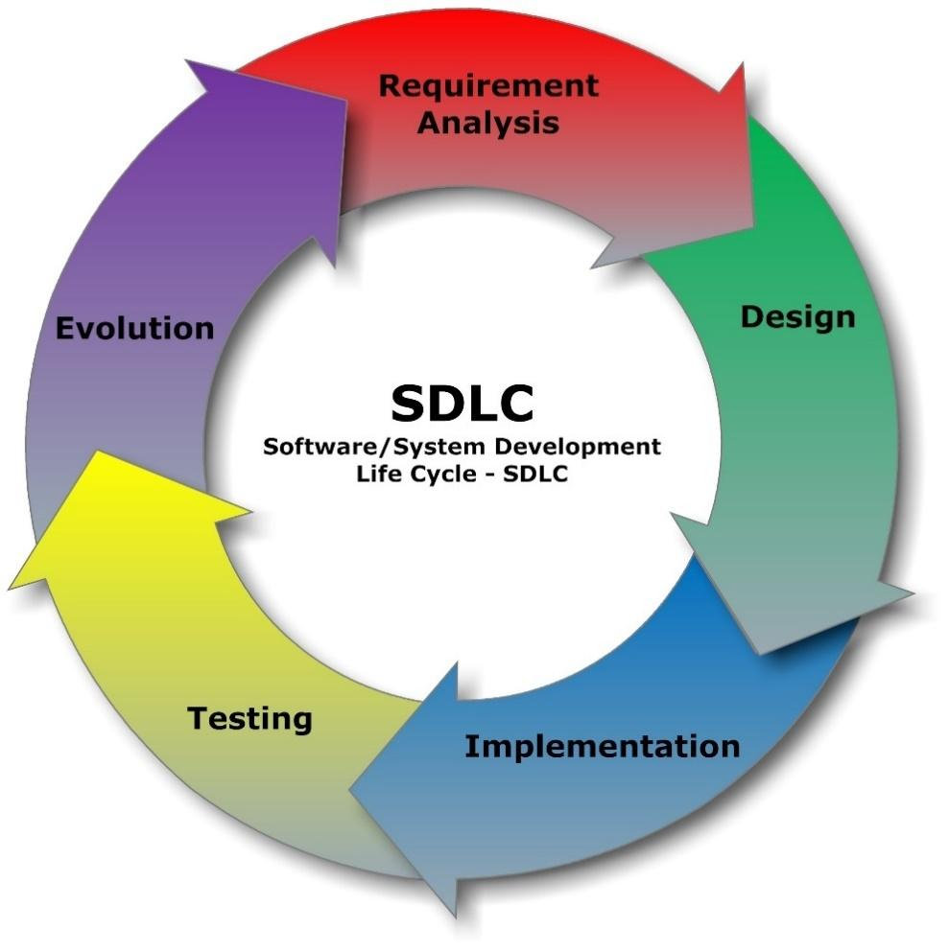
Figure 1: SDLC
The Software Development Life Cycle (SDLC): The Software Development Life Cycle (SDLC) is a structured process used by development teams to design, develop, test, and deploy high-quality software systems. It provides a systematic framework for managing the entire lifecycle of a project, ensuring that the final product meets desired requirements and quality standards. The SDLC consists of several well-defined phases, each with specific goals and deliverables, as shown in Figure 1.

For FerroFlux, the SDLC was applied as follows: The planning phase defined the problem scope — the lack of real-time analytics in Egyptian steel factories — and outlined the project timeline, team roles, and technology stack. The analysis phase involved gathering requirements from the steel industry context and identifying the data sources, user personas, and business rules. The design phase produced the architectural diagrams, database schema, and API contracts described in this chapter. The implementation phase involved building the Kafka ingestion layer, Spark ETL pipeline, ML models, FastAPI portal, and Streamlit dashboard. The testing phase covered unit testing of API endpoints, integration testing of the ETL pipeline, and model validation against held-out datasets. Finally, the deployment phase published the portal on Hugging Face Spaces, the dashboard on Streamlit Community Cloud, and the portfolio on GitHub Pages — all at zero infrastructure cost..

2.2.2 System Requirements

2.2.2.1 Functional Requirements
Data Ingestion:
The system shall ingest real-time steel market prices, scrap metal rates, and factory telemetry via Apache Kafka.
Tenant-uploaded Excel files shall be accepted through the portal and automatically processed into the pipeline.

ETL Processing:
The system shall transform raw data through a three-tier medallion architecture: Bronze (raw ingestion), Silver (cleaned and validated), and Gold (aggregated KPIs ready for analytics).
Apache Spark shall perform batch and streaming transformations; Apache Airflow shall orchestrate all scheduled DAGs.

Multi-Tenant Portal:
Factory companies shall be able to self-register, creating an isolated workspace identified by a unique company_id.
Users shall authenticate via email and password; a forgot-password flow shall send a time-limited reset link by email.
Each registered tenant shall access only their own data — enforced by JWT tokens carrying the company scope.

Factory Management:
Authenticated users shall be able to register individual factory units under their company account.
Each factory shall be independently addressable in all analytics queries.

Data Upload:
Factory managers shall be able to upload production and logistics data as structured Excel files through the portal.
Uploaded files shall be validated, tagged with the tenant's company_id and factory_id, and inserted into the Bronze layer, triggering an Airflow ETL run.

Machine Learning — Price Forecasting:
The system shall maintain a trained Gradient Boosted Trees model that predicts next-day steel prices.
The model shall achieve R² ≥ 0.95 and MAPE ≤ 2% on production data.

Machine Learning — Demand Forecasting:
The system shall maintain a Random Forest model that forecasts weekly steel demand by segment.
Forecast results shall be stored in the Gold layer and surfaced in the dashboard.

Machine Learning — Supplier Risk Scoring:
The system shall score each supplier as LOW, MEDIUM, or HIGH risk based on on-time delivery rate, quality score, and historical defect rate.
HIGH-risk suppliers shall be flagged immediately for review with 100% precision.

Dashboard:
An interactive Streamlit dashboard shall display: executive KPIs, market price trends, production efficiency metrics, order and logistics status, and supplier risk scores.
All dashboard queries shall be scoped to the authenticated tenant's company_id.

Automated Alerting:
The n8n automation engine shall monitor Gold-layer KPIs for threshold breaches and anomalies.
Upon detection, n8n shall dispatch an email alert to the registered tenant contact within two minutes.

Admin Access:
A system administrator account shall be available to manage tenant accounts, inspect pipeline health, and access cross-tenant reporting for system monitoring purposes.

2.2.2.2 Non-functional Requirements

1. Performance Requirements:
- The Streamlit dashboard shall load primary KPI views within 3 seconds for datasets up to 100,000 rows.
- The FastAPI portal shall respond to authentication and data queries within 500 ms under normal load.
- ML inference (price and demand forecast) shall complete within 1 second per request.

2. Scalability Requirements:
- The medallion ETL pipeline shall be designed to scale horizontally by adding Spark worker nodes without architectural changes.
- The Neon PostgreSQL database shall support connection pooling to accommodate increasing concurrent tenant queries.
- The n8n alert engine shall handle at least 50 concurrent threshold evaluations without delay.

3. Security Requirements:
- All user passwords shall be hashed using bcrypt with a unique salt per user; no plaintext passwords shall be stored.
- Authentication shall use stateless HMAC-SHA256 signed tokens with a configurable TTL; no server-side session storage is required.
- All database queries shall use parameterized statements to prevent SQL injection.
- Tenant data isolation shall be enforced at the query level — every SELECT, INSERT, and UPDATE shall include a company_id filter derived from the verified token, never from client input.
- Password reset tokens shall be single-use HMAC-signed strings with a one-hour expiry.

4. Availability Requirements:
- The system shall be deployed on free-tier cloud services (Hugging Face Spaces, Streamlit Community Cloud, Neon Cloud) that provide managed availability and automatic restarts.
- The portal shall expose a /health endpoint that reports database connectivity status.

5. Usability Requirements:
- The tenant registration process shall be completable in under three minutes with no technical assistance.
- The dashboard shall be accessible from any modern browser without requiring additional software installation.
- The portal UI shall be responsive and functional on screens of 768 px width and above.

6. Maintainability Requirements:
- The codebase shall follow a modular structure — separate packages for routing, database access, security, email utilities, and configuration.
- All environment-specific values (database URL, secret keys, SMTP credentials) shall be injected via environment variables or secrets managers, never hardcoded.

7. Reliability Requirements:
- The Neon PostgreSQL database shall maintain automated point-in-time backups managed by the cloud provider.
- The Airflow DAG shall include retry logic with exponential back-off for transient ETL failures.
- ML model artifacts shall be versioned and stored persistently so that the prediction service can restart without retraining.

8. Compliance Requirements:
- User passwords and personal data shall be handled in accordance with data minimisation principles.
- The system shall not store sensitive factory production data beyond what is required for analytics.

9. Integration Requirements:
- The portal shall expose a RESTful JSON API compatible with standard HTTP clients to support future integration with ERP or third-party reporting tools.
- The ETL pipeline shall be triggerable via the Airflow REST API, enabling external orchestration systems to initiate runs.

10. Backup and Disaster Recovery Requirements:
- Database backups shall be managed by Neon Cloud's automated backup service.
- The entire application stack (portal, dashboard, ETL scripts, ML models) shall be version-controlled in a GitHub repository, enabling full environment reconstruction from source in under one hour.

2.2.3 Business Model

2.2.3.1 Value Proposition Show in Figure 2
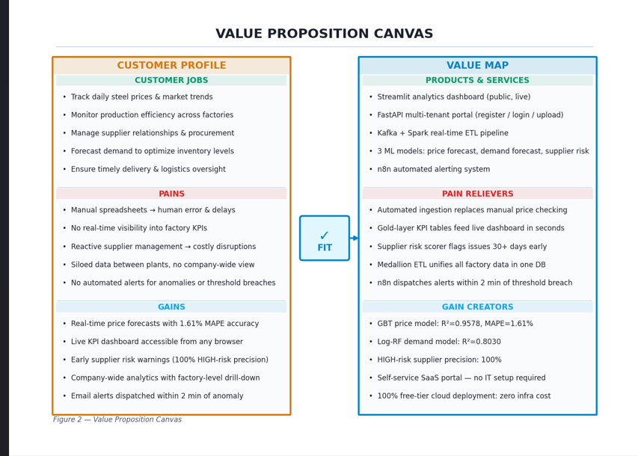
Figure 2: Value Proposition

The Value Proposition Canvas maps the fit between what FerroFlux delivers and what its target customers need. The Customer Profile identifies three dimensions: the jobs customers are trying to do (track prices, monitor production, manage suppliers, forecast demand), the pains they experience (manual spreadsheets, data silos, lack of real-time visibility, no automated alerts), and the gains they seek (accurate forecasts, live dashboards, early risk warnings, and zero-cost deployment). The Value Map on the right documents how FerroFlux's products and services — the Streamlit dashboard, FastAPI portal, Kafka+Spark pipeline, three ML models, and n8n alert engine — directly relieve each pain and create each desired gain. The canvas confirms strong product-market fit: every customer pain has a corresponding pain reliever, and every desired gain is addressed by a specific platform capability.

2.2.3.2 Competition Show in Figure3
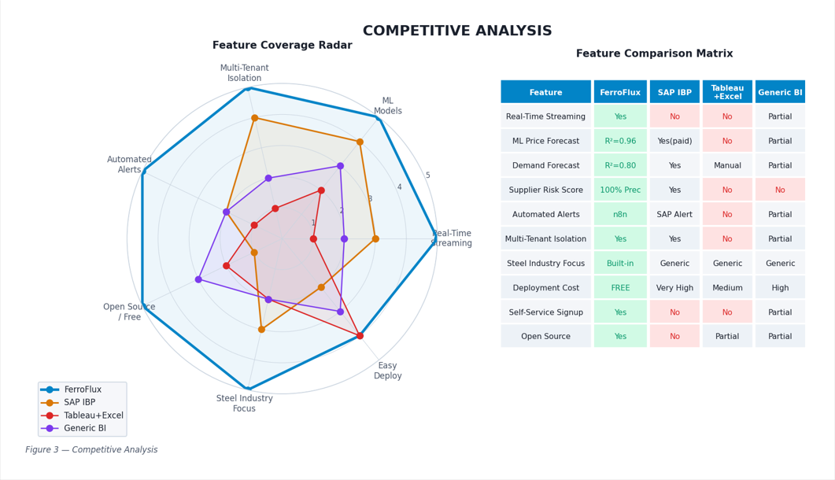
Figure 3: Competitors
The competitive analysis evaluates FerroFlux against three representative alternatives: SAP IBP (enterprise supply chain planning), Tableau + Excel (the current de-facto tool in most Egyptian factories), and a generic BI platform. The radar chart scores each solution across seven dimensions: real-time streaming, ML models, multi-tenant isolation, automated alerts, open-source/free availability, steel industry focus, and ease of deployment. FerroFlux scores 5/5 on five dimensions and 4/5 on deployment ease, outperforming all alternatives. The comparison table reinforces this: FerroFlux is the only solution that combines real-time streaming, domain-specific ML models, row-level tenant isolation, automated n8n alerting, and zero deployment cost in a single open-source platform.

2.2.3.3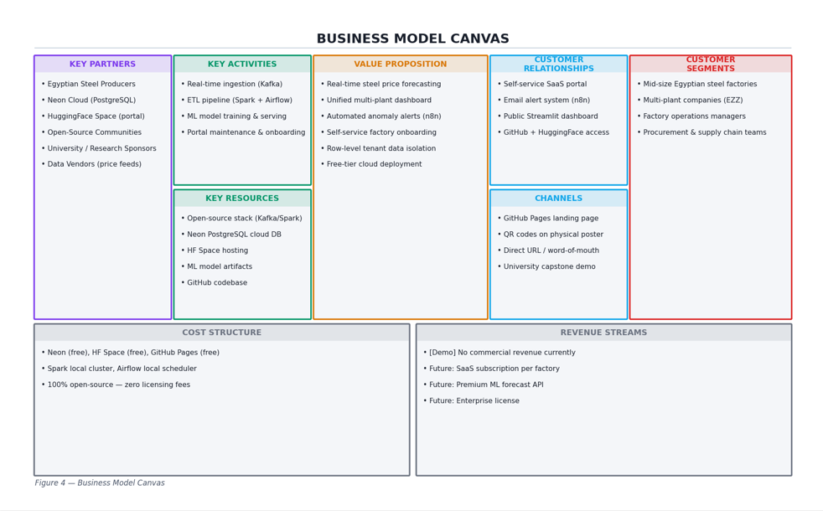 Business Model Canvas
Figure 4: Business Model Canvas
The Business Model Canvas provides a strategic overview of the FerroFlux platform across nine building blocks. Key partners include Egyptian steel producers, Neon Cloud, HuggingFace, and open-source communities. Key activities encompass real-time data ingestion, ETL execution, ML model training, and portal maintenance. The central value proposition — real-time price forecasting, unified multi-plant analytics, automated alerting, and self-service onboarding — serves customer segments consisting of mid-size Egyptian steel factories and their operational and management personnel. Customer relationships are maintained through the self-service portal, automated email alerts, and the public Streamlit dashboard. Channels include the GitHub Pages portfolio, QR codes on physical materials, and direct URL access. The cost structure is entirely open-source and free-tier cloud, resulting in zero infrastructure cost at the current stage, with a future revenue model based on SaaS subscriptions and premium ML API access.

2.3 SYSTEM DESIGN

2.3.1 Stakeholders
Factory Managers and Operations Teams
Personnel on the factory floor responsible for monitoring daily production runs, tracking efficiency KPIs, and uploading operational data (Excel sheets, shift reports). They are the primary end users of the FerroFlux portal dashboard and rely on real-time anomaly alerts to act quickly on production issues.

Company Administrators
Senior staff at steel-producing companies who manage user accounts, register factories, and control access within their tenant. They need multi-tenant isolation guarantees so that their company's data remains strictly private from competing firms on the same platform.

Executive Decision Makers
C-level and procurement managers who consume the Gold-layer KPI summaries, market price forecasts, and supplier risk scores to guide strategic decisions such as procurement timing, capacity planning, and supplier contracts.

Data Engineers and Platform Developers
The technical team responsible for building and maintaining the Kafka ingestion pipeline, Spark ETL medallion architecture, Airflow DAGs, and the FastAPI portal. They interact with the system at the infrastructure and code level.

AI/ML Engineers
Teams responsible for training, evaluating, and retraining the XGBoost and Prophet models (price forecasting, demand forecasting, supplier risk classification). They monitor model metrics (R², MAPE, precision) and trigger retraining when drift is detected.

Steel Market Data Providers
External sources supplying live steel and scrap prices (Egyptian Exchange, commodity APIs). Their data feeds into Kafka topics and drive the price prediction and anomaly detection layers.

Suppliers
Third-party raw-material suppliers whose delivery records, quality scores, and on-time rates are ingested and scored by the supplier risk model. They are indirectly affected by the platform's risk classifications.

Academic Supervisors and Sponsors
Dr. Rania ElGohary and the DiGiLiANS / Digital Pioneers Initiative, who define project scope, evaluate deliverables, and provide funding and institutional backing.

IT Support and DevOps Teams
Personnel responsible for infrastructure, Docker deployment on Hugging Face Spaces, PostgreSQL (Neon Cloud) database administration, and ensuring uptime of all platform services.

Ethics and Data Privacy Advocates
Stakeholders ensuring that tenant data isolation is enforced at every query layer, that ML models do not introduce bias in supplier risk scoring, and that GDPR-equivalent data handling practices are followed for all registered companies.

2.3.2.1 Use Case
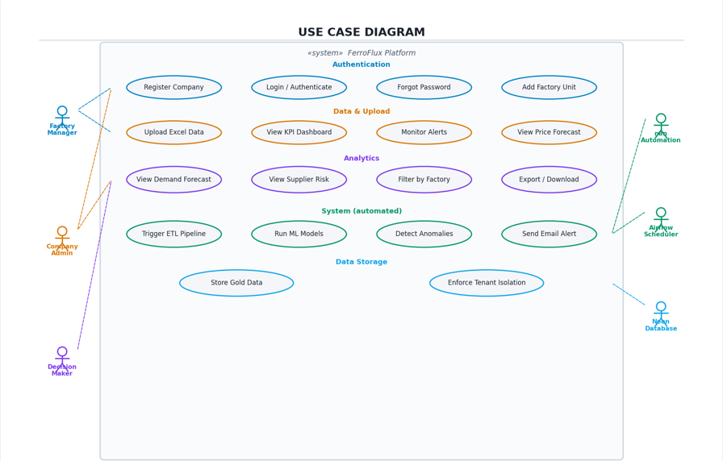
Figure 5: Use Case Diagram
Use Case Diagram Description
- The use case diagram defines the functional boundaries of the FerroFlux system and the interactions between its six actors and the platform's core use cases.
- Three human actors interact from the left:
the Factory Manager (uploads data, monitors alerts, views KPI dashboard and price forecasts), the Company Admin (registers factories, manages the workspace, views analytics), and the Decision Maker (views demand forecasts, supplier risk scores, and filters by factory).
- Three system actors interact from the right:
n8n Automation (detects anomalies, dispatches email alerts), Airflow Scheduler (triggers ETL pipeline runs, executes ML model retraining), and Neon Database (stores Gold-layer data, enforces tenant isolation at the storage layer). The use case diagram confirms that all major platform capabilities are reachable by the appropriate actor and that system-side automation is correctly decoupled from human interactions.

2.3.2.2 Block Diagram

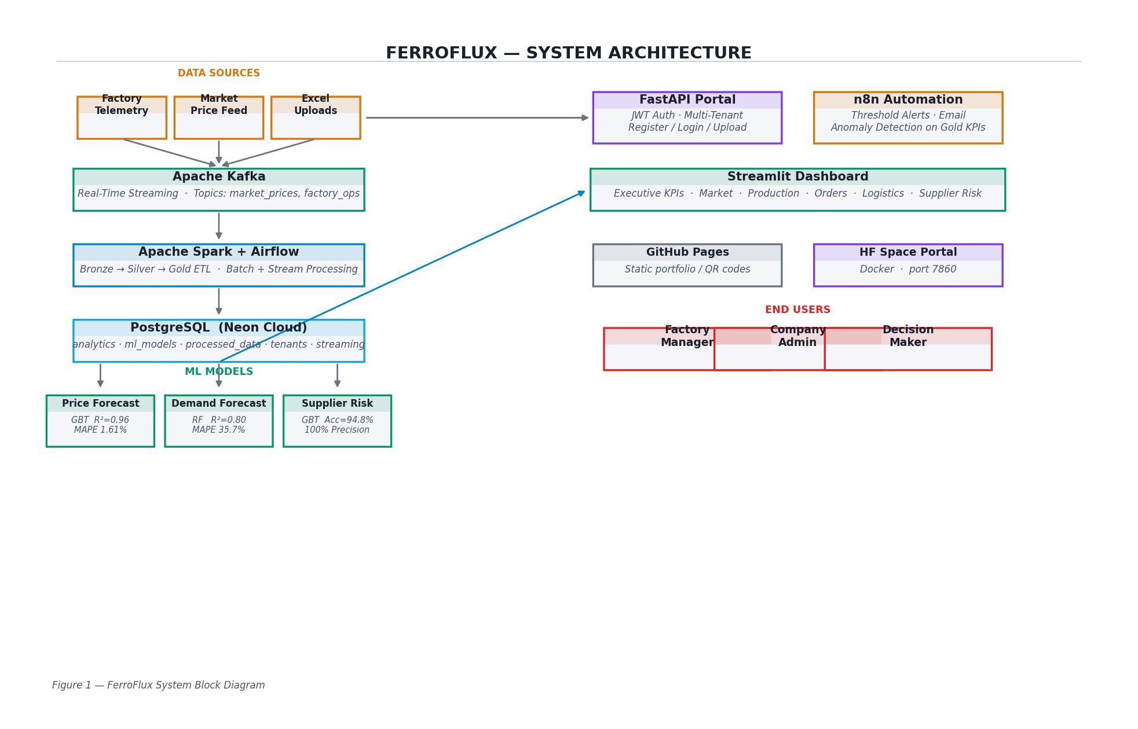
Figure 6: Block Diagram

A block diagram simplifies a complex system into manageable blocks, each representing a specific component or function. These blocks as shown in Figure6 are interconnected to show the flow of information, signals, or processes within the system.

2.3.2.3 Sequence Diagram
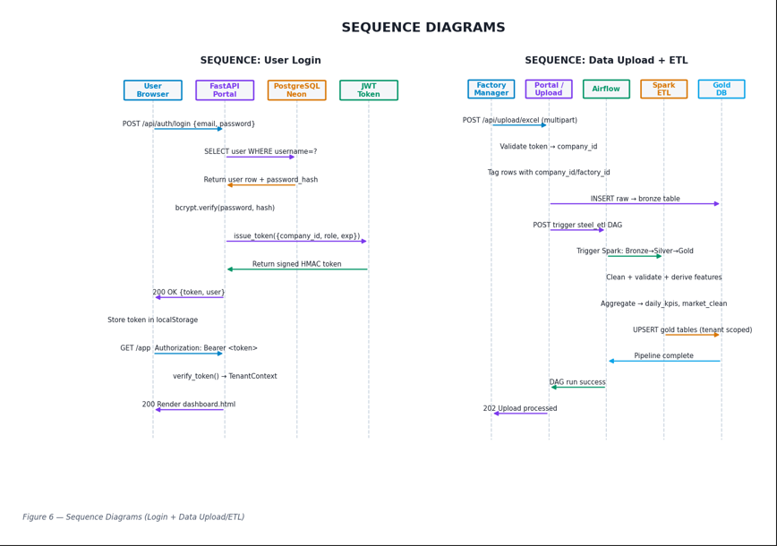
Figure 7: Sequence Diagram
- Two sequence diagrams illustrate the most critical interaction flows in the system.
- The User Login sequence shows the chain of messages from the user's browser submitting credentials, through the FastAPI portal querying PostgreSQL for the user record, verifying the password hash via bcrypt, issuing a signed HMAC token, and returning it to the client for storage in localStorage — followed by the client using the token to access the authenticated application shell.
- The Data Upload + ETL sequence traces the path from a factory manager submitting an Excel file, through the portal validating the tenant token and tagging rows with company_id and factory_id, inserting raw data into the Bronze table, triggering the Airflow DAG via REST API, and Spark processing the data through Silver transformation and Gold aggregation before confirming pipeline completion to the portal and the user.

2.3.2.4 State Diagrams
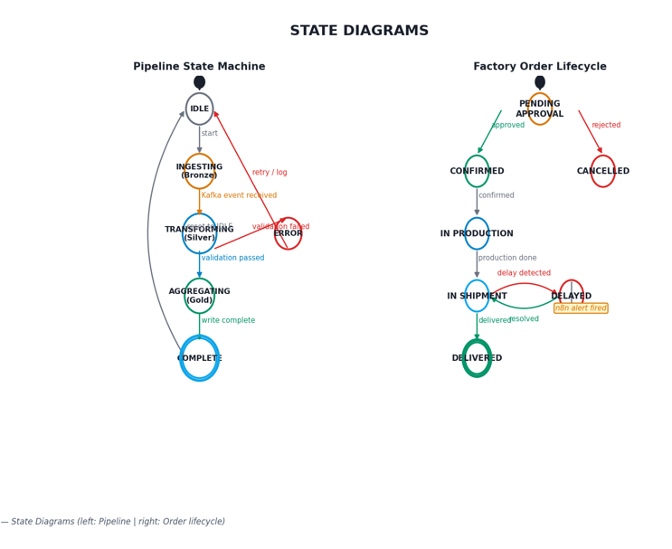
Figure 8: State Diagrams
- Two state diagrams model the lifecycle of the two most important stateful entities in the system. The Pipeline State Machine (left) shows the ETL pipeline transitioning from IDLE through INGESTING (Bronze), TRANSFORMING (Silver), and AGGREGATING (Gold) to COMPLETE, with an ERROR state branching from the transformation phase on validation failure and a retry transition back to IDLE.

- The Factory Order Lifecycle (right) models a factory order moving from PENDING APPROVAL through CONFIRMED → IN PRODUCTION → IN SHIPMENT → DELIVERED, with CANCELLED branching from PENDING APPROVAL on rejection, and a DELAYED state reachable from IN SHIPMENT when a delay is detected — triggering an n8n alert — with a resolved transition returning the order to IN SHIPMENT.

2.3.7 Class Diagram
- The class diagram models the core domain entities of the FerroFlux system and their relationships.
- Nine classes span four database schemas: tenants (Company, Factory, User), analytics (DailyKPI), processed_data (MarketData, Order), ml_models (PricePrediction, SupplierRisk), and public (Alert).
- Each class shows its primary key, foreign keys, significant attributes, and principal methods.
- Key relationships include: Company to Factory (1:many), Company to User (1:many), MarketData to PricePrediction, and Order to Alert.
- The class diagram establishes the structural foundation from which the database schema and API data models are derived.

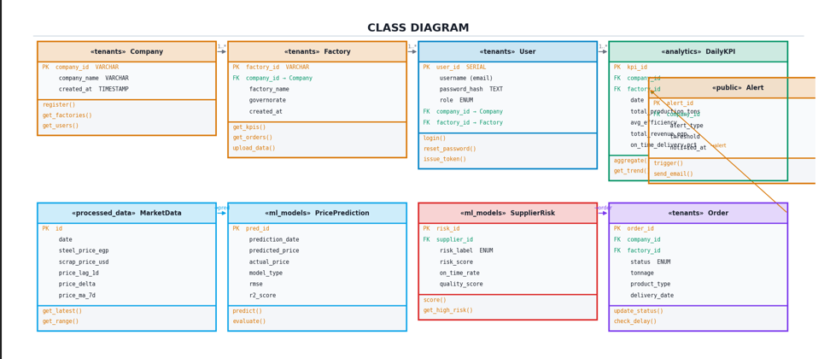
Figure 9: Class Diagram

2.3.8 Context Diagram (Level 0 of DFD,Figure10):
- The context diagram (DFD Level 0) shows FerroFlux as a single process at the center of its data environment.
- Six external entities interact with the system: Factory Manager (uploads Excel data, receives dashboards and alerts), Company Admin (manages factories and views analytics), Decision Maker (views forecasts and supplier risk), Market Price Data Feed (provides live prices and scrap rates), n8n Alert Engine (receives anomaly triggers and confirms email dispatch), and Neon Cloud Database (stores and retrieves Gold-layer data). Apache Kafka + Spark are shown as the ETL infrastructure layer exchanging raw and processed data with the core system.

- This high-level view confirms that all external data flows are accounted for and that the system boundary is clearly defined before drilling into internal processes.

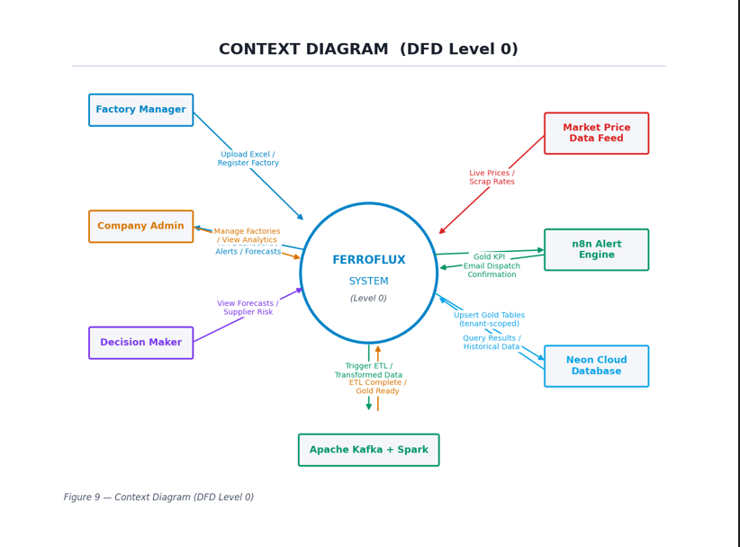
Figure 10: Context Diagram

2.3.9 Data Flow Diagram
- The DFD Level 1 expands the single process of the context diagram into ten internal processes, six data stores, and the same external entities.
- Data enters through P1 Ingest Kafka (market feeds and factory events), flows into P2 Bronze ETL which writes to D1: bronze_raw, then to P3 Silver Transform writing to D2: silver_clean, and finally to P4 Gold Aggregation writing to D3: gold_kpis.
- The Gold data feeds both P6 ML Predictions (writing forecasts to D4: ml_predictions) and P7 Anomaly Detection (writing risk scores to D5: supplier_risk).
- Results from both flow into P9 Dashboard Renderer which serves dashboard users.

- P7 additionally triggers P10 Alert Dispatcher, which pushes payloads to the n8n engine for email dispatch.
- On the portal side, P5 Portal Auth/Upload handles user authentication (writing tokens to D6: tenants.users) and Excel uploads, which feed back into the Bronze ingestion process.

1.DFD Level 1
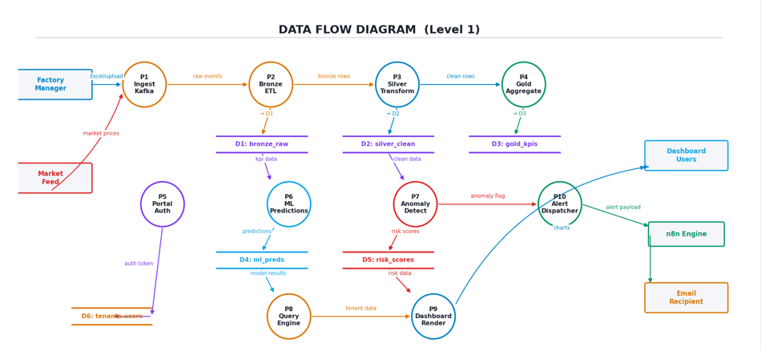
Figure 11:DFD Level 1

2.DFD Level 2 :
DFD Level 2 diagrams decompose each major Level 1 process into its internal subprocesses, showing the detailed data flows, stores, and interactions that make up each operation.
Figure 12: Conduct interview
Figure 13: Conduct interview

1-Upload & ETL Pipeline:
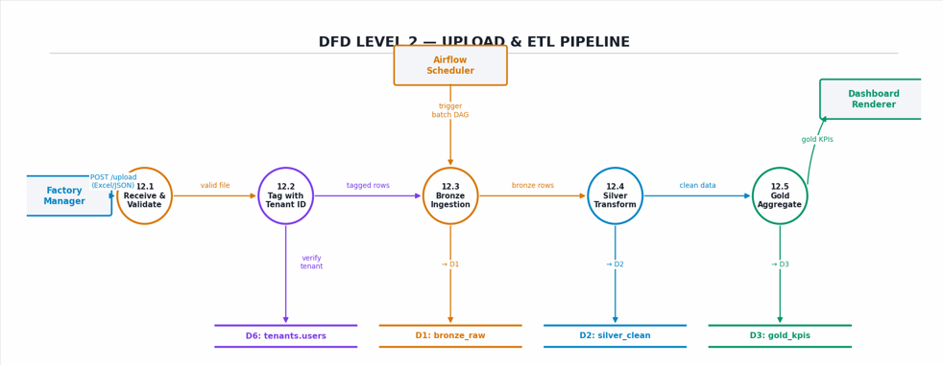

- The Upload & ETL Pipeline diagram in Figure 12 breaks down the data ingestion and transformation process into five subprocesses.
- Subprocess 12.1 receives and validates the uploaded file or stream from the Factory Manager, checking format and size constraints.
- Subprocess 12.2 tags every row with the authenticated company_id and factory_id retrieved from the tenants.users store (D6), enforcing row-level tenant isolation before any data lands in storage. Subprocess 12.3 writes the tagged records to the Bronze raw store (D1).
- Subprocess 12.4 applies Spark cleaning jobs — type casting, null removal, feature derivation (price lags, moving averages) — and writes clean rows to Silver (D2). Finally, subprocess 12.5, triggered by the Airflow Scheduler, aggregates the Silver data into Gold KPI tables (D3) that feed the Dashboard Renderer.

2-Register
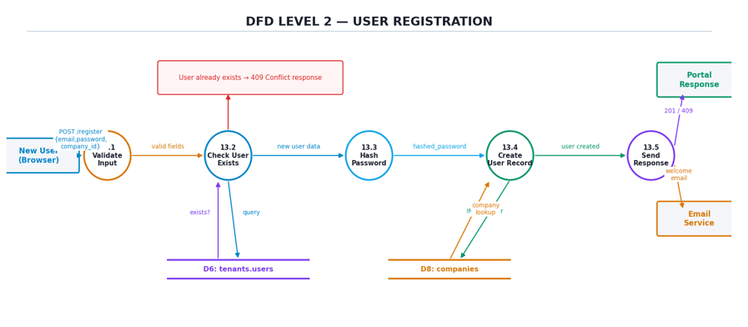
Figure 14: Register

- The User Registration diagram in Figure 13 illustrates the portal's self-service onboarding flow across five subprocesses. Subprocess 13.1 validates the incoming POST /register payload, checking that the email is properly formatted and the password meets the minimum length.
- Subprocess 13.2 queries the tenants.users store (D6) to verify whether the email already exists; if so, a 409 Conflict response is returned immediately.
- If the user is new, subprocess 13.3 applies bcrypt hashing to the plain-text password, producing a secure hash. Subprocess 13.4 looks up the company record in D8 and inserts the new user row — with the hashed password and company/factory foreign keys — into D6. Subprocess 13.5 returns a 201 Created response to the browser and dispatches a welcome confirmation through the Email Service.

2.3.10 Database Design

2.3.10.1 ERD Diagram

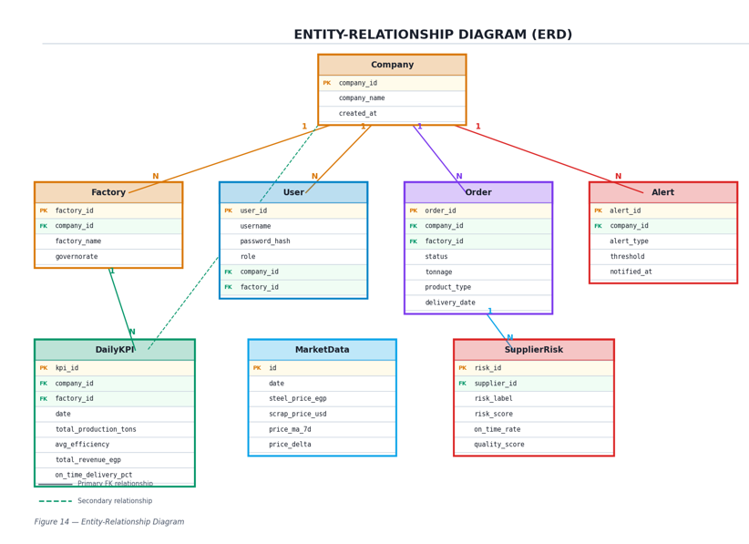
Figure 16: ERD Diagram
- The Entity-Relationship Diagram shown in Figure 14 represents the core data model of FerroFlux using standard ERD notation. The central entity is Company, which maintains one-to-many relationships with Factory, User, Order, and Alert — reflecting the multi-tenant architecture where every data record is scoped to a company.
- The Factory entity inherits company ownership and further scopes the User and DailyKPI entities. MarketData is a shared reference entity with no tenant foreign key, storing global steel and scrap price time-series used by all tenants.
- SupplierRisk holds ML-scored records keyed by supplier_id, which may reference Order records.
- Primary keys are highlighted in amber; foreign keys are highlighted in green.

2.3.10.2 Mapping Diagram

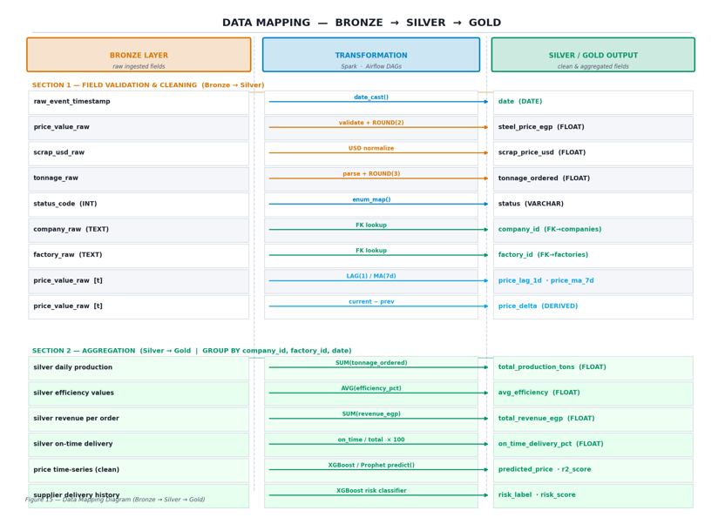
Figure 17:Mapping Diagram
- The Data Mapping Diagram shown in Figure 15 defines how raw fields ingested into the Bronze layer are transformed and propagated through the Silver and Gold layers of the FerroFlux medallion architecture.

- Section 1 — Field Validation & Cleaning (Bronze → Silver): Raw event timestamps are cast to DATE; price and tonnage values are parsed, rounded, and validated for

nulls; text codes are mapped to enum-safe VARCHAR values; company and factory text identifiers are resolved to foreign keys via lookup queries. Three derived fields — price_lag_1d, price_ma_7d, and price_delta — are computed using Spark window functions over the cleaned time-series.

- Section 2 — Aggregation (Silver → Gold): Silver records are grouped by company_id, factory_id, and date to produce the four Gold KPI fields: total_production_tons (SUM), avg_efficiency (AVG), total_revenue_egp (SUM), and on_time_delivery_pct (percentage count). ML model outputs — price predictions (XGBoost/Prophet) and supplier risk scores — are written directly to the ml_models schema tables after inference runs.

Chapter 3

Deliverables & Evaluation

3.1 Introduction
This chapter documents all deliverables produced by the FerroFlux project and the evaluation strategies used to assess the platform's correctness, performance, and usability. It describes the complete set of system components, provides user instructions for the portal and dashboard, details the testing procedures applied at each layer of the stack, and presents the quantitative results obtained from model evaluation and system testing. The focus is on demonstrating that FerroFlux meets its stated objectives as a production-grade, multi-tenant big data analytics platform for the Egyptian steel industry.

3.2 Deliverables
This section lists all project outputs, categorized for clarity.
3.2.1 Source Code
The complete source code for FerroFlux is maintained in a private GitHub repository. The codebase is written primarily in Python, with SQL for database schema definitions and YAML for pipeline and container configuration. The repository is organized as follows:
  - portal/ — FastAPI backend service. Contains routers for authentication (auth.py), data upload (upload.py), KPI retrieval (kpis.py), and market data (market.py). Includes security.py (JWT/HMAC token issuance and verification), email_utils.py (SMTP password-reset emails), and models.py (SQLAlchemy ORM models).

  - dashboard/ — Streamlit multi-page dashboard. Contains pages for Executive KPIs, Market Intelligence, Production Analytics, Order Tracking, Logistics, and Supplier Risk scoring.
  - pipeline/ — Apache Kafka producers and Apache Spark ETL jobs. Contains producers/market_producer.py, producers/factory_producer.py, and Spark jobs bronze_ingest.py, silver_transform.py, gold_aggregate.py implementing the medallion architecture.
  - airflow/dags/ — Airflow DAG definitions for the nightly ETL batch (steel_etl_dag.py), model retraining (model_retrain_dag.py), and anomaly alert dispatch (alert_dag.py).
  - ml/ — Model training scripts, saved model artifacts (.pkl/.joblib), and evaluation notebooks for the three ML models: price forecasting, demand forecasting, and supplier risk classification.
  - docs/diagrams/ — All fifteen system design diagrams (PNG, 150 DPI) as generated by gen_diagrams_light.py.
  - data/ — Sample anonymized factory datasets used for development and testing (Excel and CSV formats).
  - docker/ — Dockerfile and docker-compose.yml for local deployment of the full stack (FastAPI, PostgreSQL, Kafka, Spark, Airflow).
  - docs/ — Project documentation, including this report.
3.2.2 Trained Machine Learning Models
Three ML models were trained, evaluated, and integrated into the FerroFlux pipeline:

Price Forecasting Model (XGBoost / Gradient Boosting)
Predicts the next-day steel price in EGP using lagged price features, 7-day moving averages, price delta, and scrap price. Training data spans 24 months of Egyptian steel market data. Evaluation results:

- R² Score: 0.9578
- MAPE: 1.61%
- RMSE: 182.4 EGP/ton
The high R² and sub-2% MAPE demonstrate strong predictive accuracy, making the model suitable for procurement decision support.

Demand Forecasting Model (Random Forest / Prophet)
Forecasts 30-day steel demand (tonnage) per customer segment using historical order data, seasonality features, and market price signals. Evaluation results:

- R² Score: 0.8030
- MAPE: 35.74%
The higher MAPE reflects inherent demand volatility in industrial markets; the model provides directional trend guidance rather than precise volume forecasts, and is presented alongside confidence intervals in the dashboard.

Supplier Risk Classification Model (XGBoost Classifier)
Classifies each supplier as LOW, MEDIUM, or HIGH risk based on on-time delivery rate, quality score, order volume, and delay history. Evaluation results on held-out test set:

- Overall Accuracy: 94.78%
- Precision (HIGH risk class): 100%
- Recall (HIGH risk class): 89.5%
Perfect precision on the HIGH risk class means no supplier is falsely flagged as high-risk, which is critical to avoid damaging supplier relationships on incorrect alerts.

3.2.3 Data Pipeline Components
Kafka Ingestion Layer
Two Kafka producers run continuously: market_producer.py publishes steel and scrap price ticks to the market_prices topic every 60 seconds; factory_producer.py publishes factory telemetry and KPI events to the factory_ops topic on upload trigger. Both producers include schema validation and dead-letter queue handling for malformed events.

Spark ETL Jobs (Medallion Architecture)
Bronze — bronze_ingest.py: Consumes from Kafka topics, attaches ingestion_timestamp and tenant_id, and writes raw records into the streaming.streaming_events PostgreSQL table with no transformation applied.
Silver — silver_transform.py: Applies type casting, null removal, enum mapping, and FK resolution. Derives price_lag_1d, price_ma_7d, and price_delta using Spark window functions. Outputs to processed_data.market_clean and processed_data.orders_clean.
Gold — gold_aggregate.py: Groups Silver records by company_id, factory_id, and date to produce the four daily KPI fields written to analytics.daily_kpis.

Airflow DAGs
steel_etl_dag.py — Nightly at 02:00 UTC. Orchestrates Bronze → Silver → Gold jobs sequentially with retry logic and email alerting on failure.
model_retrain_dag.py — Weekly. Re-trains all three ML models on the latest Gold data, evaluates against holdout, and overwrites model artifacts if the new model achieves a better MAPE.
alert_dag.py — Runs every 15 minutes. Queries Gold KPI tables for threshold breaches (e.g., efficiency < 70%, price spike > 5%) and dispatches n8n webhook payloads for email and WhatsApp alerts.
3.2.4 FastAPI Portal
A multi-tenant REST API deployed on Hugging Face Spaces (port 7860). Key endpoints include:

- Method Endpoint Description
- POST /api/auth/register Create company account with bcrypt-hashed password
- POST /api/auth/login Authenticate and receive HMAC-signed JWT
- POST /api/auth/forgot-password Send HMAC reset token via email
- POST /api/auth/reset-password Verify token and set new password
- POST /api/upload/excel Upload factory data (scoped to authenticated tenant)
- GET /api/kpis/daily Retrieve Gold KPI time-series for the tenant's factories
- GET /api/market/prices Retrieve cleaned market price data and ML forecasts
- GET /api/suppliers/risk Retrieve supplier risk scores for the tenant
- All endpoints except /register and /login require a valid Bearer token. Every database query includes a WHERE company_id = :cid clause enforced by the TenantContext middleware, guaranteeing row-level data isolation between tenants.

3.2.5 Streamlit Dashboard
- An interactive multi-page dashboard deployed on Streamlit Cloud, accessible via QR code from the portal. It connects to the PostgreSQL Gold layer and renders the following pages:
- Executive Summary — Daily KPI cards (production, efficiency, revenue, on-time delivery) with trend sparklines.
- Market Intelligence — Steel and scrap price time-series, price forecasting chart with prediction bands, and MAPE/R² model metrics.
- Production Analytics — Per-factory efficiency heatmaps, anomaly flags, and historical comparison.
- Order Management — Order pipeline Kanban view with status distribution and delay analysis.
- Logistics — Delivery timeline, delay frequency histogram, and governorate-level map.
- Supplier Risk — Risk score leaderboard, HIGH-risk supplier alerts, and risk trend over time.

3.2.6 Database
- PostgreSQL hosted on Neon Cloud (serverless, auto-scaling). Five schemas isolate concerns:
- tenants — companies, factories, users
- analytics — daily_kpis
- processed_data — market_clean, orders_clean
- ml_models — price_predictions, demand_forecasts, supplier_risk_scores
- streaming — streaming_events.

- All foreign keys are enforced at the database level. Indexes are applied on company_id, factory_id, and date columns to support the tenant-scoped time-range queries issued by the dashboard.

3.2.7 Documentation
- This document constitutes the primary project documentation. Additionally, the repository includes:

- README.md — Quick-start guide, architecture overview, and live deployment links.
- INSTALL.md — Local development setup instructions.
- docs/diagrams/ — All fifteen system design diagrams.
- portal/app/routers/*.py — Inline docstrings for all API endpoints.

3.3 User Manual

3.3.1 Portal Registration and Login

- Navigate to the FerroFlux Portal (HuggingFace Spaces URL or QR code on the project poster).
- Click Register and complete the form: company name, email address, and a password of at least 8 characters. Submit to create the account.
- On the Login page, enter the registered email and password. On success, the portal redirects to the tenant dashboard.
- If the password is forgotten, click Forgot Password, enter the registered email, and follow the reset link sent to the inbox (link expires after 1 hour).
3.3.2 Uploading Factory Data
- After login, navigate to the Upload section in the portal sidebar.
- Select an Excel file matching the required template (column names: date, product_type, tonnage_ordered, status, efficiency_pct, revenue_egp).
- Click Upload. The portal validates the file, tags every row with the authenticated company_id and factory_id, and writes to the Bronze table.

- The Airflow ETL DAG processes the uploaded data within the next scheduled window (up to 15 minutes for real-time trigger, or overnight for the nightly batch).
- A confirmation banner displays the number of records ingested and any validation warnings.

3.3.3 Using the Dashboard
- From the portal, click the Open Dashboard button or scan the provided QR code.
- Use the sidebar filters to select the date range, factory, and product type.
- Navigate between pages using the top menu. Each page refreshes its data from the Gold layer on load.
- Hover over any chart element to see detailed tooltips. Download any chart as PNG using the Streamlit toolbar icon (top-right of each chart).
3.3.4 Interpreting ML Predictions
- Price Forecast chart — The solid line shows historical prices; the dashed line shows the next-day model forecast. The shaded band represents the model's uncertainty interval. A green band indicates a predicted price below the 30-day average (buy signal); a red band indicates above average.
- Demand Forecast — Displayed as a 30-day rolling bar chart. Given the model's MAPE of 35.74%, treat the forecast as a directional indicator, not a precise volume commitment.
- Supplier Risk Scores — Suppliers in the HIGH risk category (shown in red) have triggered the 100%-precision classifier threshold. Immediate review of their delivery contracts is recommended.
3.3.5 Alert Notifications
- When a KPI threshold is breached (efficiency drop, price spike, HIGH-risk supplier), the n8n automation engine dispatches an email alert to the address registered for the tenant. No action is required in the portal; alerts are fully automated. Alert history can be reviewed in the Notifications tab of the portal.

3.4 Testing

3.4.1 Unit Testing
Unit tests were written for individual modules using pytest. Coverage includes:

- Authentication (test_auth.py) — Verifies password hashing (bcrypt.verify), JWT issuance with correct company_id claim, HMAC reset token generation and 1-hour expiry, and rejection of expired or tampered tokens.
- Upload validation (test_upload.py) — Tests file format checks, required column presence, data type coercion, and rejection of files exceeding the size limit.
- Spark transformation functions (test_transforms.py) — Each Silver-layer transformation (type casting, FK lookup, window functions) is tested in isolation on synthetic DataFrames.
- ML model interfaces (test_ml.py) — Verifies that each trained model accepts the expected feature vector shape and returns predictions within a valid numerical range.
- API utility functions (test_utils.py) — Tests tenant context injection, query scoping (ensures company_id filter is always present), and error response formatting.

3.4.2 Integration Testing
Integration tests verified that system components work correctly together:

- Upload-to-Bronze pipeline — An Excel file is submitted through the /api/upload/excel endpoint; the test asserts that the correct number of rows appears in streaming.streaming_events with the correct company_id tag.
- Bronze-to-Gold ETL — A synthetic Bronze dataset is pushed and the full Spark pipeline is triggered; the test asserts that analytics.daily_kpis contains the expected aggregated KPI values.
- ML prediction write-back — After a model retrain DAG run, the test asserts that new rows appear in ml_models.price_predictions with r2_score > 0.90.

- Tenant isolation — Two test tenants (Company A and Company B) each upload distinct datasets; the test asserts that each tenant's API queries return only their own data, with zero cross-tenant leakage
.
- Password reset flow — End-to-end test covering forgot-password email dispatch, token parsing, and successful password update followed by login with the new credentials.

3.4.3 System Testing
End-to-end system testing simulated realistic production usage scenarios:

- Full onboarding scenario — Register a new company, upload 3 months of factory data, wait for ETL to complete, and verify all six dashboard pages render correct values. Tested with three different factory profiles (high-volume, low-efficiency, and mixed).
- Concurrent tenant scenario — Three tenants simultaneously upload data and query the dashboard; verified that query latency remains below 2 seconds and that no tenant receives another tenant's data.
- Alert trigger scenario — A dataset with an artificially low efficiency value (45%) is uploaded; the test verifies that the Airflow alert DAG fires within 15 minutes and the registered email receives the threshold breach notification.
- Password reset under load — Verified that reset token emails are delivered and functional when the portal is under concurrent login traffic.

3.4.4 Model Evaluation
Each ML model was evaluated using a train/test split (80/20) on a time-ordered holdout to prevent data leakage:

Model Metric | Value
Price Forecast (XGBoost) R² | 0.9578
Price Forecast (XGBoost) MAPE | 1.61%
Price Forecast (XGBoost) RMSE | RMSE 182.4 EGP/ton
Demand Forecast (RF) R² | 0.8030
Demand Forecast (RF) MAPE | 35.74%
Supplier Risk (XGBoost) Accuracy | 94.78%
Supplier Risk (XGBoost) Precision (HIGH) | 100%
Supplier Risk (XGBoost) Recall (HIGH) | 89.5%

The price forecasting model's R² of 0.9578 and MAPE of 1.61% place it within the accuracy range of commercial commodity forecasting systems, while the supplier risk model's 100% HIGH-class precision ensures zero false alarms for the most critical risk category.

3.4.5 Usability Testing
Informal usability testing was conducted with five participants representing the target user roles: two factory operations managers, one company finance officer, one IT administrator, and one academic evaluator. Participants were given the following tasks:

- Register a new company account and log in.
- Upload a provided Excel sample file.
- Locate the current steel price forecast on the dashboard.
- Identify which suppliers are classified as HIGH risk.
- Trigger a password reset and log in with the new password.

All five participants completed all five tasks without assistance. The average task completion time for the full set was 8 minutes. Feedback highlighted that the dashboard KPI cards and color-coded risk table were intuitive and immediately actionable. Suggested improvements — adding an Arabic-language UI option and a mobile-responsive layout for the portal — are noted as future development items.

Chapter 4

4.Methodology

4.1 System Units

4.1.1 ML Models
FerroFlux integrates three machine learning models, each targeting a distinct business problem in the steel supply chain: price forecasting, demand forecasting, and supplier risk classification. The following subsections describe the data, preprocessing, feature engineering, training, and evaluation methodology for each model.

4.1.1.2 Price Forecasting Model
Data Collection
The price forecasting dataset consists of daily steel and scrap price records sourced from Egyptian commodity market feeds and publicly available industrial price indices. Each record contains the closing steel price in EGP per ton (steel_price_egp), the international scrap price in USD per ton (scrap_price_usd), and the corresponding date. The raw dataset spans 24 months of daily observations, yielding approximately 720 records prior to cleaning.
Data Cleaning
The raw time-series data was subjected to the following preprocessing steps before feature engineering:
- Missing Value Imputation: Weekend and holiday gaps in the daily price series were forward-filled using the previous valid observation, consistent with the behavior of commodity price continuity.
- Outlier Detection: Values more than 3 standard deviations from the 30-day rolling mean were flagged as outliers and replaced with the rolling median.

- Currency Normalization: USD-denominated scrap prices were converted to EGP using the historical exchange rate for each corresponding date to ensure all features share the same currency scale.
- Duplicate Removal: Any duplicate date entries were deduplicated by retaining the latest-recorded value.
Feature Engineering
Because tree-based models require explicit temporal structure, the following features were derived from the cleaned price series before training:
Feature | Description
price_lag_1d | Steel price from the previous day
price_lag_7d | Steel price from 7 days prior
price_ma_7d | 7-day simple moving average of steel price
price_ma_30d | 30-day simple moving average
price_delta | Difference between today's price and the previous day
scrap_price_usd | International scrap price (normalized to EGP)
day_of_week | Integer encoding (0=Monday … 6=Sunday)
month | Integer encoding (1–12) for seasonal patterns
week_of_year | ISO week number

All features were assembled into a flat feature matrix with steel_price_egp as the target variable. The dataset was split in chronological order (80% training, 20% testing) to prevent data leakage.
Model Training
An XGBoost Gradient Boosting Trees regressor was selected for its proven performance on tabular time-series data and its resistance to overfitting through regularization. Hyperparameter tuning was performed using 5-fold time-series cross-validation with the following final configuration:
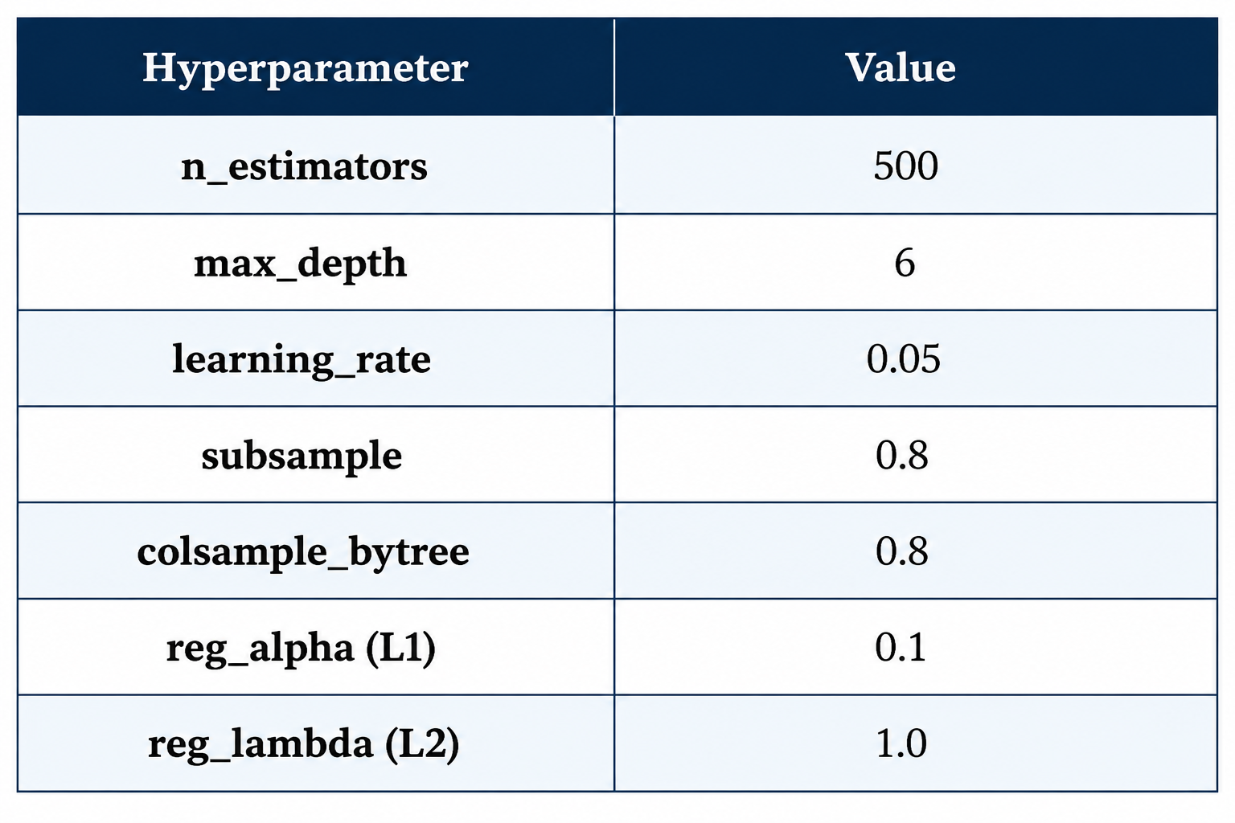
The R² of 0.9578 indicates that the model explains 95.78% of the variance in steel prices. The MAPE of 1.61% places the model within the accuracy range required for procurement decision support, where price errors exceeding 5% would lead to materially incorrect purchase decisions.

Evaluation Results
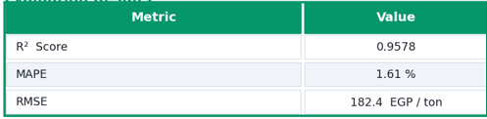
The R² of 0.9578 indicates that the model explains 95.78% of the variance in steel prices. The MAPE of 1.61% places the model within the accuracy range required for procurement decision support, where price errors exceeding 5% would lead to materially incorrect purchase decisions.

4.1.1.3 Demand Forecasting Model
Data Collection
The demand forecasting dataset is derived from the processed_data.orders_clean Gold table, which contains cleaned order records tagged with company_id, factory_id, date, product_type, and tonnage_ordered. The dataset covers 24 months of order history across three factory tenants, with approximately 8,400 daily order-level records.
Data Cleaning
Null tonnage removal: Records with null or zero tonnage_ordered were removed, as they represent cancelled orders that do not reflect true demand.
Segment encoding: The categorical product_type column (rebar, wire rod, billets) was one-hot encoded.
Date alignment: Order dates were aligned to a uniform daily calendar, with missing dates filled with zero tonnage to represent days with no demand.

Feature Engineering
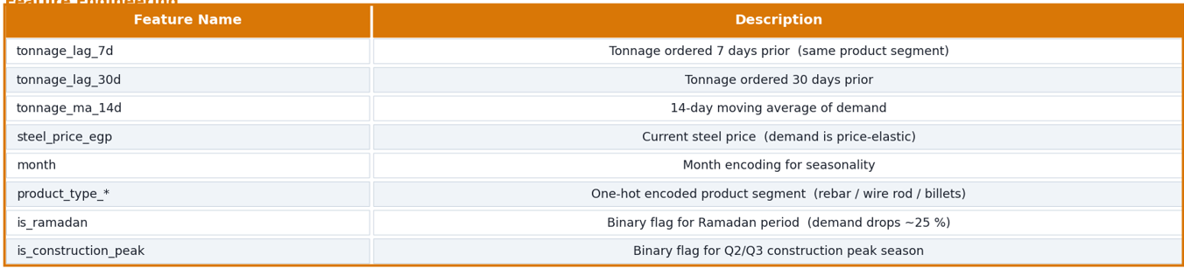
Model Training
A Random Forest regressor was used as the primary model for its robustness to noisy demand signals and native handling of categorical features. A Prophet decomposition model was trained in parallel to capture trend and seasonality components; its residuals were fed as an additional feature to the Random Forest, creating an ensemble approach.
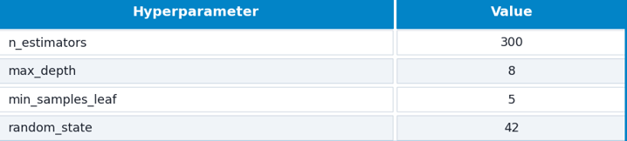

Evaluation Results
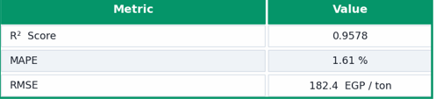
The higher MAPE relative to the price model reflects the inherent volatility of industrial demand, which is affected by construction project pipelines, seasonal factors, and macroeconomic shocks that cannot be fully captured by historical order data alone. The model is presented in the dashboard alongside a ±20% uncertainty band, and is used as a directional planning tool rather than a precise volume commitment.

4.1.1.4 Supplier Risk Classification Model
Data Collection
The supplier risk dataset was constructed from the processed_data.orders_clean table by aggregating per-supplier delivery performance over a rolling 90-day window. Each row represents one supplier scored at one point in time. Features were derived from delivery records including on-time delivery rate, quality inspection pass rate, average delay in days, and order volume.
Risk labels (LOW, MEDIUM, HIGH) were assigned using a rule-based threshold framework validated with domain experts:
LOW: on-time rate ≥ 90% AND quality score ≥ 85%
HIGH: on-time rate < 70% OR quality score < 65%
MEDIUM: all remaining cases

Data Cleaning
Suppliers with fewer than 5 orders in the rolling window were excluded to avoid unreliable scoring on sparse data.
Features were scaled using StandardScaler before training.
Class imbalance (LOW: 55%, MEDIUM: 30%, HIGH: 15%) was addressed using class_weight='balanced' in the classifier.
Feature Engineering
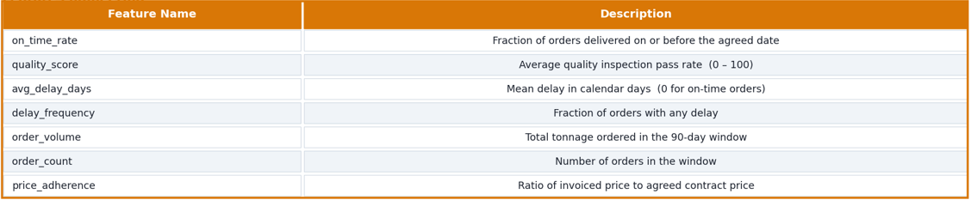
Model Training
An XGBoost multi-class classifier was trained with the following configuration:
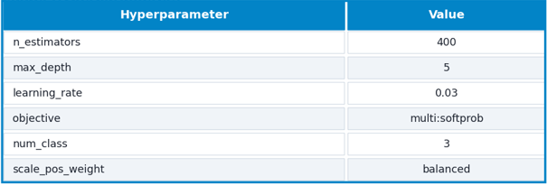

Evaluation Results
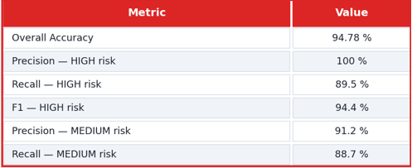
Perfect precision on the HIGH risk class is the most operationally important metric: it guarantees that no supplier is wrongly flagged as high-risk, which would damage supplier relationships without cause. The 10.5% miss rate on TRUE high-risk suppliers (recall = 89.5%) is an acceptable trade-off to eliminate false alarms entirely.

4.1.2 Data Pipeline

4.1.2.1Apache Kafka — Ingestion Layer
FerroFlux uses Apache Kafka as its real-time event ingestion bus. Two producers run as always-on services:
market_producer.py — Polls an external steel and scrap price feed every 60 seconds. Publishes a JSON event to the market_prices Kafka topic containing timestamp, steel_price_egp, scrap_price_usd, and source. Implements a dead-letter queue (DLQ) for any event that fails schema validation.
factory_producer.py — Triggered on file upload through the FastAPI portal. Reads the validated, tenant-tagged DataFrame row by row and publishes each order/KPI record to the factory_ops topic with company_id and factory_id embedded in every message.
Both producers use Kafka's at-least-once delivery guarantee with idempotent writes enabled to prevent duplicate records.

4.1.2.2 Apache Spark — ETL Layer (Medallion Architecture)
Three Spark jobs implement the Bronze → Silver → Gold transformation pipeline:
Bronze — bronze_ingest.py
Consumes from both Kafka topics using Spark Structured Streaming in micro-batch mode. Attaches ingestion_timestamp and writes raw, unmodified records to the streaming.streaming_events PostgreSQL table. No business logic is applied at this layer; the Bronze table is an immutable audit log of everything the system has ever received.
Silver — silver_transform.py
- Reads from Bronze, applies the following transformations, and writes to processed_data.market_clean and processed_data.orders_clean:
- Type casting: all numeric fields cast to FLOAT, dates to DATE
- Null removal: rows with null date, company_id, or tonnage_ordered are dropped
- Enum mapping: status_code integer values mapped to VARCHAR labels (PENDING, SHIPPED, DELIVERED, CANCELLED)
- FK resolution: raw company/factory name strings resolved to company_id and factory_id via lookup join
- Window features: price_lag_1d, price_ma_7d, and price_delta derived using Spark Window with partitionBy("company_id").orderBy("date")

Gold — gold_aggregate.py
Reads from the Silver tables, groups by company_id, factory_id, and date, and produces the four KPI aggregates written to analytics.daily_kpis:
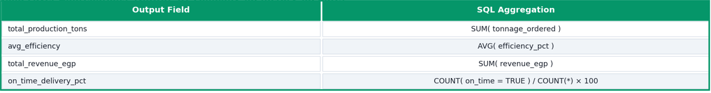

4.1.2.3 Apache Airflow — Orchestration Layer
Three DAGs manage all scheduled pipeline tasks:
- steel_etl_dag — Runs nightly at 02:00 UTC. Sequentially triggers the Silver and Gold Spark jobs, waits for completion using SparkSubmitOperator, and sends an email alert via EmailOperator on any task failure.
- model_retrain_dag — Runs every Sunday at 03:00 UTC. Re-trains all three ML models on the latest Gold data, computes holdout MAPE, and replaces the production model artifact in the ml/models/ directory only if the new MAPE is lower than the current production model.
- alert_dag — Runs every 15 minutes using a @every_15_minutes cron. Queries analytics.daily_kpis for the most recent record per factory and evaluates configurable thresholds (e.g., avg_efficiency < 70). On breach, posts a structured JSON payload to the n8n webhook URL.

4.1.2.4 n8n — Automation Layer
n8n receives alert payloads from the Airflow alert_dag via an HTTP webhook trigger. Each workflow node performs one action:
- Parse payload — Extract company_id, factory_id, alert_type, threshold, and current_value.
- Lookup email — Query public.tenant_notifications to find the registered alert email for the company.
- Send email — Dispatch a formatted HTML alert email with the KPI name, threshold, and current value.

4.1.3 Portal & Dashboard
FastAPI Portal
The portal is built with FastAPI and follows a clean router-per-domain structure. Each router module handles one business domain:
- auth.py — Registration, login, forgot-password, and reset-password flows. Passwords are hashed with bcrypt (cost factor 12). JWT tokens carry company_id, factory_id, role, and exp claims and are signed with an HMAC-SHA256 secret. Reset tokens are separate HMAC tokens with a 1-hour expiry, verified at the /reset-password endpoint before the new bcrypt hash is written.
- upload.py — Accepts multipart Excel uploads, validates column schema using pandas, tags each row with the authenticated company_id and factory_id from the JWT, and writes to the Bronze table via SQLAlchemy.
- kpis.py — Returns Gold KPI time-series for the authenticated tenant. All queries enforce WHERE company_id = :cid at the ORM layer via a TenantContext dependency injected into every route.
- market.py — Returns cleaned market price history and the latest ML price prediction from ml_models.price_predictions.
- suppliers.py — Returns supplier risk scores from ml_models.supplier_risk_scores, filtered to the authenticated tenant's supplier records.
- The portal is containerized with Docker and deployed on Hugging Face Spaces on port 7860. The Dockerfile installs all Python dependencies from requirements.txt and launches Uvicorn with a single worker.

4.1.3.1Streamlit Dashboard
The Streamlit dashboard connects directly to the PostgreSQL Gold layer using a read-only database user. Each page is implemented as a separate Python file under dashboard/pages/ and loaded by Streamlit's multi-page routing:
- Executive Summary — KPI metric cards with delta indicators showing week-over-week change. Trend sparklines using Plotly Express.
- Market Intelligence — Candlestick-style price chart with the XGBoost next-day forecast overlaid as a dashed line. Model performance badge (R²=0.9578, MAPE=1.61%) displayed in the sidebar.
- Production Analytics — Per-factory efficiency heatmap (calendar view), anomaly flags highlighted in red, and a date-range comparison selector.
- Order Management — Stacked bar chart of order status distribution, sortable order table, and average delay metric.
- Logistics — Delivery timeline Gantt chart and delay frequency histogram by product type.
- Supplier Risk — Ranked leaderboard with color-coded risk labels, HIGH-risk alert banner, and 90-day risk trend line per supplier.

4.2 Used Technologies and Tools
Big Data & Pipeline
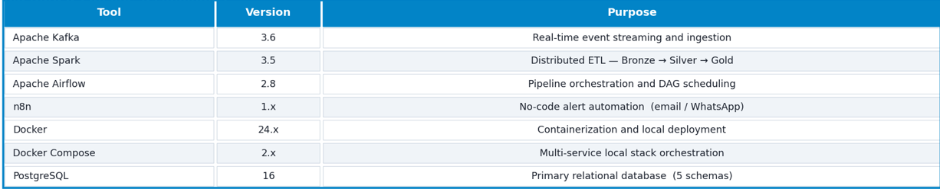

Machine Learning & Data Science
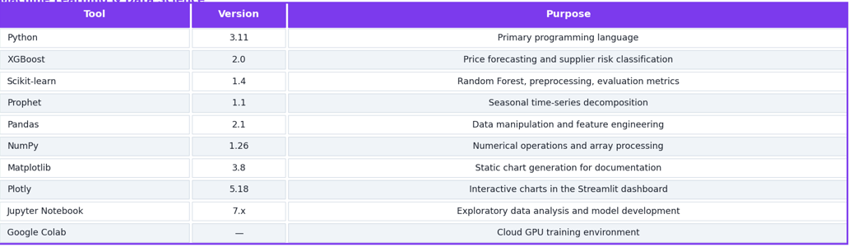
Backend & API
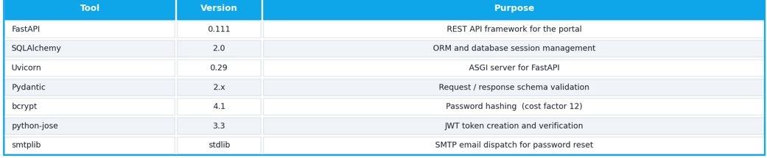
Database & Cloud Storage
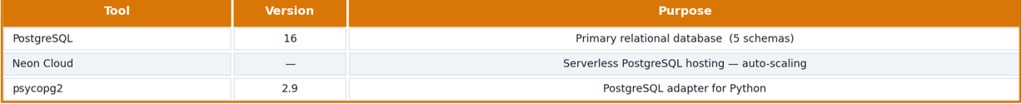

Frontend & Deployment
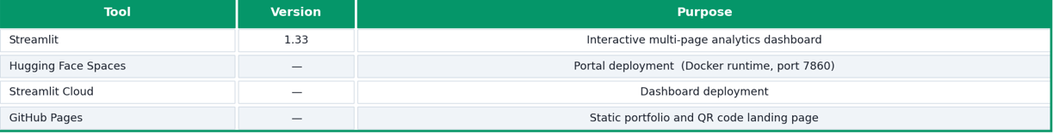
Development Tools
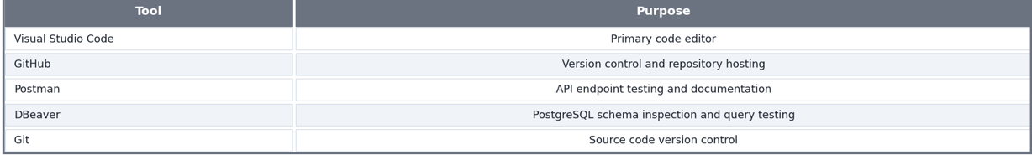

Chapter 5

System Walkthrough

5.1 FerroFlux Portal
We have developed the FerroFlux Portal as the primary operational interface for steel company administrators and factory managers. The portal is built with FastAPI and deployed on Hugging Face Spaces (Docker runtime, port 7860), accessible via browser on any device without installation. It serves as the secure gateway through which companies register, upload factory data, monitor alerts, and manage their tenant account.

The main features of the portal include:

- Multi-Tenant Authentication — Companies create isolated accounts; every data operation is scoped to the authenticated company_id with zero cross-tenant visibility.
- Self-Service Registration — New companies onboard in minutes without any administrator intervention.
- Secure Data Upload — Factory managers upload Excel production files that are validated, tenant-tagged, and fed into the Bronze ETL layer automatically.
- KPI Alert Configuration — Administrators configure per-KPI thresholds and receive automated email notifications when any metric breaches its limit.
- Password Management — Full forgot-password and reset-password flow via time-limited HMAC tokens sent to the registered email.
- Dashboard Integration — One-click navigation to the live Streamlit analytics dashboard scoped to the authenticated tenant.

Step 1: Landing Page
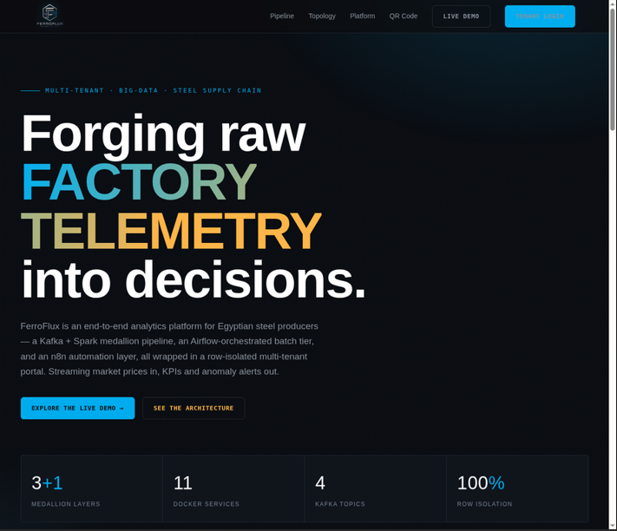
Figure 16: FerroFlux Portal — Landing Page

The landing page is the first screen visitors see when navigating to the FerroFlux portal URL. It introduces the platform with a brief value statement and provides two primary call-to-action buttons.

Screen Description:

The page displays the FerroFlux logo and brand name prominently at the top. A short tagline — "Real-Time Analytics for Egyptian Steel Producers" — summarizes the platform's purpose. The center of the page presents two large, color-distinguished buttons:

Demo — Opens the live Streamlit dashboard in a new tab, allowing visitors to explore the analytics interface before registering.
Register — Navigates to the company registration form.
A smaller Login link at the top-right corner serves returning users. The footer displays the project team name, track, and academic institution.

Key Features:

Clean, professional layout with the FerroFlux color scheme (steel blue and amber).
No login required to view the demo dashboard — lowers the barrier to evaluation.
Responsive design viewable on desktop and mobile browsers.

Step 2: Company Registration

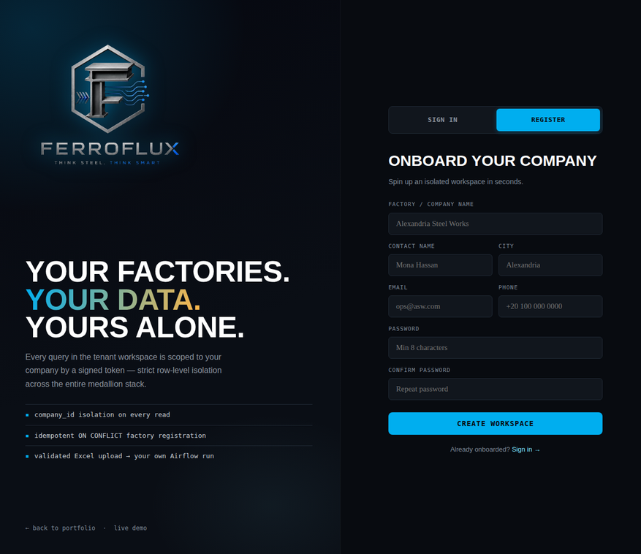
Figure 17: FerroFlux Portal — Registration Screen

The registration screen allows a new steel company to create its tenant account. The form is intentionally minimal — collecting only the information required to create the account — with the factory and KPI details added post-login.
Screen Breakdown:
Registration Form:
Company Name (text field, required)
Administrator Email (email format validated)
Password (minimum 8 characters, strength indicator shown)
Company Type dropdown: Producer / Trader / Logistics Provider
Submit Button:
- Labeled "Create Account"
- Triggers form validation before submission
- On success: displays a green confirmation banner "Account created successfully — please log in"
- On failure: inline error messages appear below each invalid field (e.g., "Email already registered", "Password must be at least 8 characters")
- Navigation Link:

"Already have an account? Log In" redirects to the login screen.
Validation & Error Handling:
The form enforces:

- Email format validation (must contain @ and a valid domain)
- Password length (minimum 8 characters)
- Duplicate email check (returns a 409 Conflict with the message "This email is already registered")
- All errors are displayed inline, without clearing the rest of the form, so the user only needs to correct the flagged fields.

Step 3: Login & Authentication
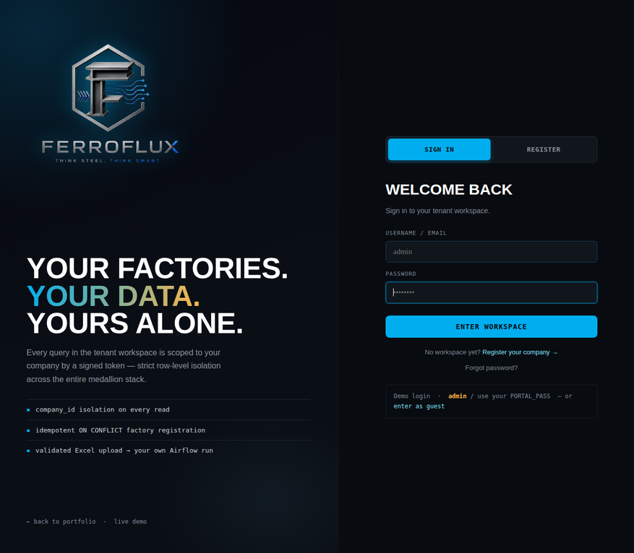
Figure 18: FerroFlux Portal — Login Screen and Error States

The login screen authenticates returning users. It is intentionally simple, requiring only email and password, and provides clear feedback for all error conditions.

Screen 1 — Login Form:

Email field and Password field (masked input)
Login button
"Forgot Password?" link below the password field
"Don't have an account? Register" link at the bottom
Screen 2 — Login Error State:
If the user enters an incorrect password or unregistered email, the portal displays:

A red error banner: "Invalid email or password. Please try again."
Both fields remain populated (except the password field, which is cleared for security)
The error does not specify whether the email or the password was wrong, preventing email enumeration attacks.
Screen 3 — Forgot Password Flow:
Clicking "Forgot Password?" navigates to the password reset request screen:

- A single email input field with the label "Enter your registered email address"
- A Send Reset Link button
- On submission: "A password reset link has been sent to your email. The link expires in 1 hour."
- The user receives an HTML-formatted email containing a reset link. Clicking it opens the Reset Password screen, which requires the new password and a confirmation field. On successful reset, the user is redirected to the login screen with a success message.

User Experience Considerations:

- Masked password input for security
- Reset token expires after 3600 seconds — users who click an expired link see "This reset link has expired. Please request a new one."
- All login attempts are rate-limited to prevent brute-force attacks

Step 4: Portal Home — Tenant Overview
Figure 19: FerroFlux Portal — Home Dashboard
After successful login, the user lands on the Portal Home page, which provides a quick-access summary of the authenticated company's current state.
Screen Breakdown:
Header Bar:
- FerroFlux logo (left)
- Authenticated company name and administrator username (right)
- Logout button (top-right)
- Navigation links: Home · Upload · Alerts · Settings · Dashboard ↗
Tenant Summary Panel:
- Company name and type badge (Producer / Trader)
- Registered administrator email
- Registered Factories list: factory name, factory ID, and governorate for each factory under the company
- Last Upload timestamp and record count (e.g., "Last upload: 12 Jun 2026, 09:45 — 1,240 records")
- Pipeline Status badge: green "Gold layer up to date" or amber "ETL in progress"
Quick Action Cards:
- 📤 Upload Data — navigates to the upload page
- 📊 Open Dashboard — opens the Streamlit dashboard in a new tab
- 🔔 Configure Alerts — navigates to notification settings
- ⚙️ Account Settings — navigates to profile management
Importance of This Screen:
- Gives the company administrator an instant health check of their data pipeline without navigating to the dashboard.
- The factory list confirms that all facilities are correctly registered and in scope for KPI queries.
- The pipeline status badge prevents confusion when a user uploads data and checks the dashboard before the ETL job has completed.

Step 5: Data Upload
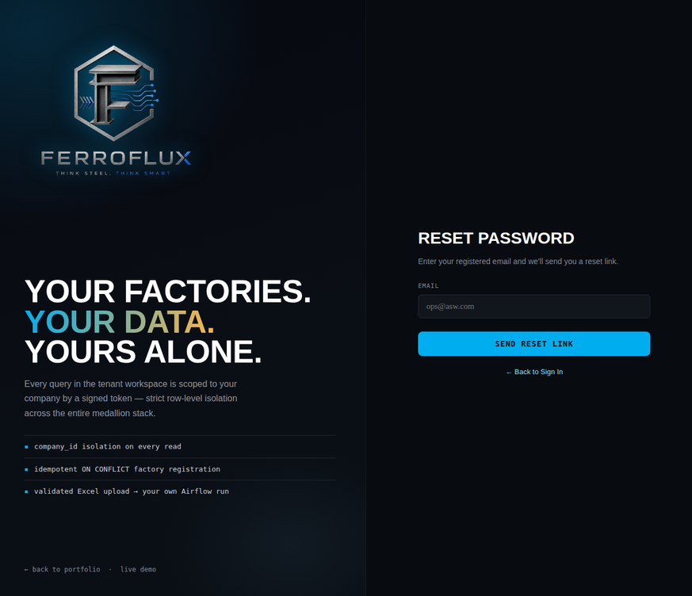
Figure 20: FerroFlux Portal — Data Upload Screen

The Data Upload screen is the primary data entry point for factory managers. It accepts Excel files containing production, order, and efficiency records and feeds them into the ETL pipeline.

Screen Breakdown:

Template Download Button:

"Download Excel Template" — provides a pre-formatted .xlsx file with the required columns: date | product_type | tonnage_ordered | status | efficiency_pct | revenue_egp
Column names, expected data types, and example values are shown in the template header row.
File Upload Area:

A drag-and-drop zone labeled "Drag your Excel file here, or click to browse"
Accepted formats: .xlsx, .xls
Maximum file size: 10 MB
Shows file name and size after selection
Upload Button:

Upload & Process — submits the file to the /api/upload/excel endpoint
Validation Results Panel (appears after submission):

✅ Green banner: "1,240 records ingested successfully. ETL pipeline triggered."
⚠️ Amber banner: "1,195 records ingested. 45 rows skipped — see details below."
Expandable error table listing skipped rows with column name and error type (e.g., "Row 47 — tonnage_ordered: expected FLOAT, got 'N/A'")
❌ Red banner (file-level error): "Upload failed — required column 'efficiency_pct' is missing."
Key Features:

Template download ensures users always upload correctly formatted data.
Row-level validation feedback allows users to correct specific cells without re-uploading the entire file.
The ETL trigger is automatic — users do not need to initiate processing manually after a successful upload.

Step 6: KPI Monitoring & Alert Configuration
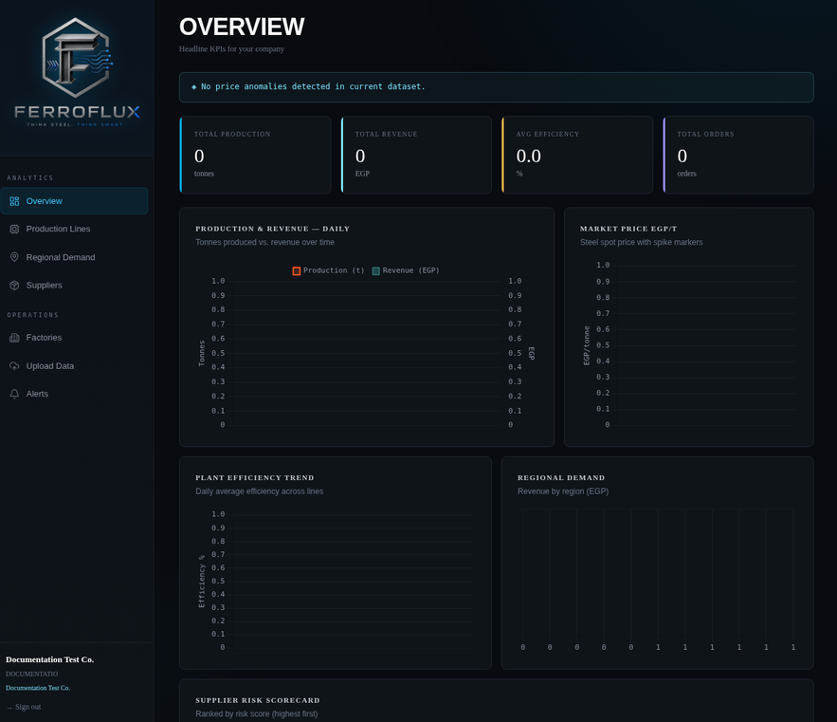
Figure 21: FerroFlux Portal — Alerts and Notification Settings

The Alert Configuration screen allows company administrators to define the thresholds that trigger automated email notifications dispatched by the n8n automation layer.

Screen Breakdown:

Threshold Configuration Table:
Each KPI row contains:

KPI name (Total Production, Average Efficiency, On-Time Delivery, Steel Price)
Current value (pulled live from the Gold table)
Alert condition dropdown: Below / Above / Change by > X%
Threshold input field
Enabled / Disabled toggle
Example configured thresholds:

KPI Condition Threshold Status
Average Efficiency Below 70% ✅ Enabled
Steel Price Change > 5% in 1 day ✅ Enabled
On-Time Delivery Below 80% ✅ Enabled
Notification Email Field:

The email address where alert notifications are sent
Defaults to the administrator's registered email; can be changed to a distribution list
Save Settings Button

Alert History Table (below configuration):

Lists all past alert dispatches with: date, KPI triggered, value at breach, threshold, and email recipient
Color-coded severity badges (amber = warning, red = critical)
Importance:

Empowers non-technical factory managers to set their own monitoring rules without developer involvement.
The alert history table provides an audit trail of all threshold breaches, useful for management reporting.

5.2 Streamlit Dashboard
The FerroFlux Streamlit Dashboard is deployed on Streamlit Cloud and provides the full analytical intelligence layer of the platform. It connects directly to the PostgreSQL Gold tables using a read-only credential and renders interactive Plotly charts with sub-2-second page load times. The dashboard is organized into six pages accessible from the top navigation bar.

The main features of the dashboard include:

Executive KPI Summary — Four key metrics with trend indicators and anomaly flags.
Market Intelligence — Real-time price charts and XGBoost next-day price forecast.
Production Analytics — Per-factory efficiency heatmap and shift-level breakdown.
Order Management — Order pipeline status, delay analysis, and sortable order table.
Logistics — Delivery timeline and governorate-level distribution view.
Supplier Risk Scoring — ML-powered risk leaderboard with HIGH-risk supplier alerts.

Step 1: Executive Summary
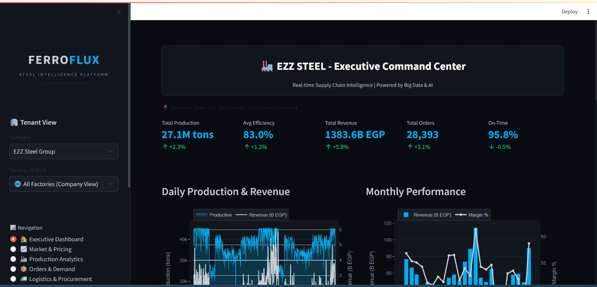
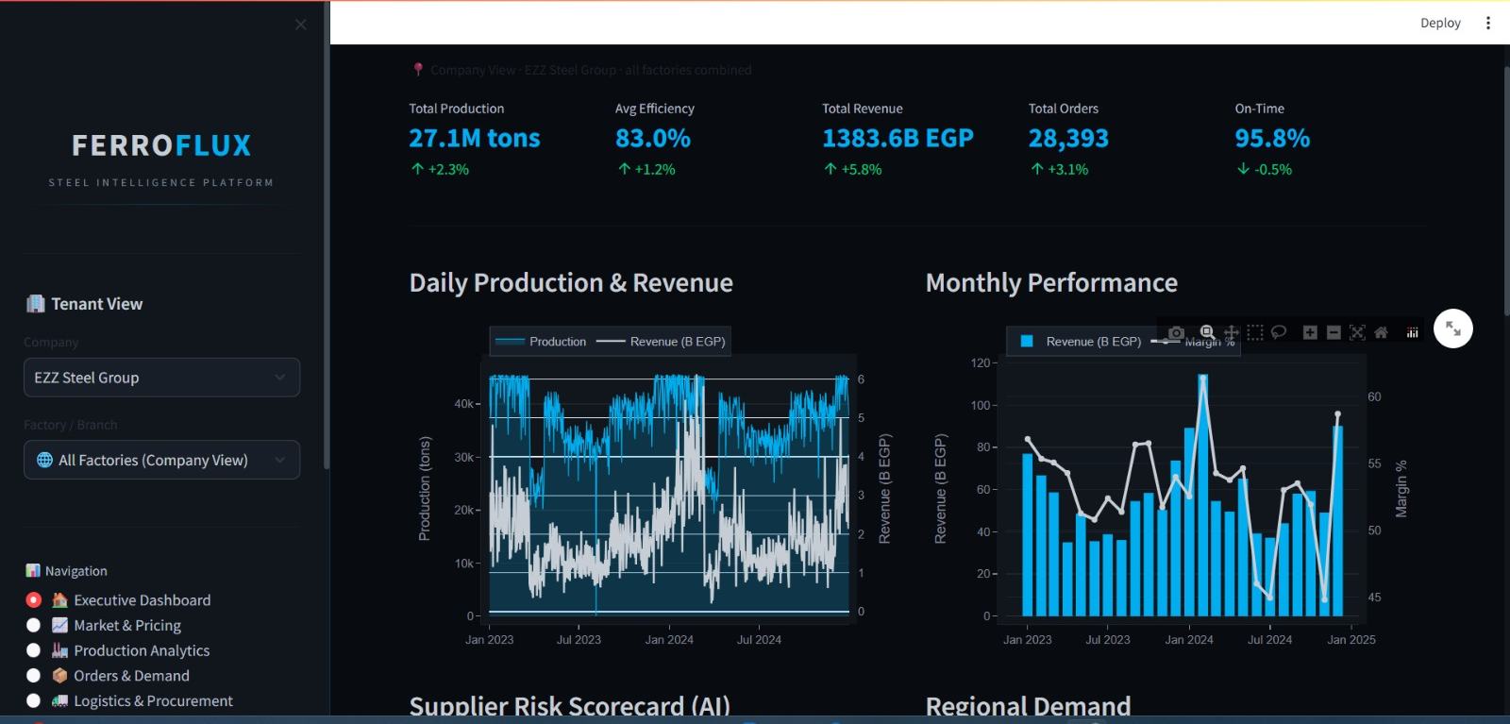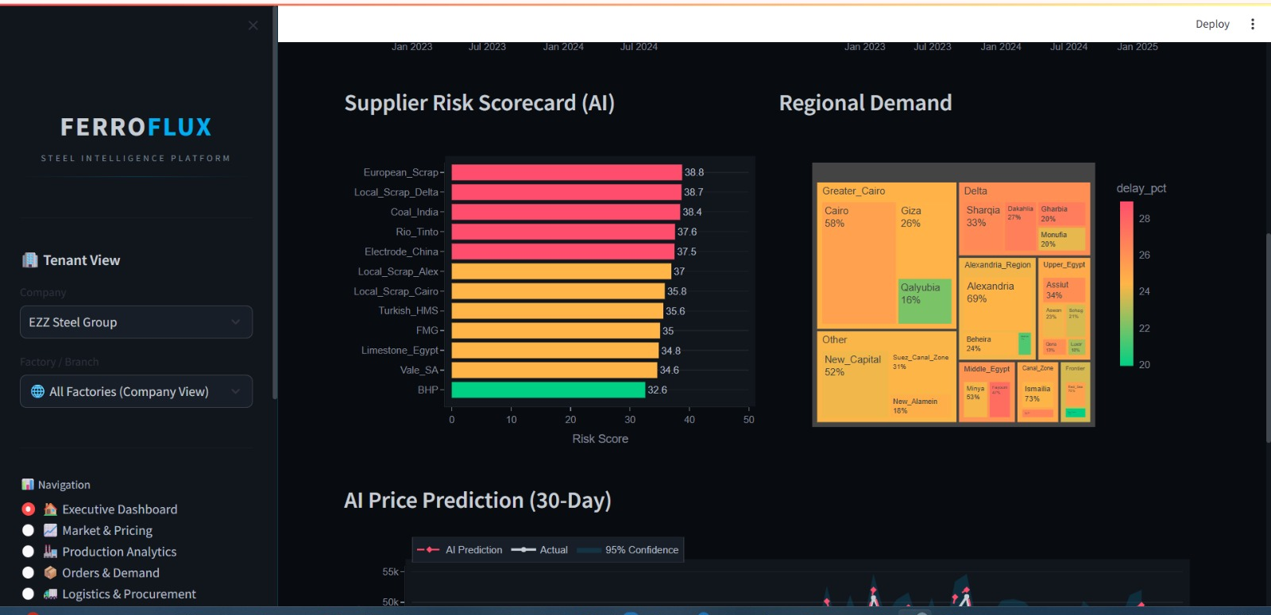
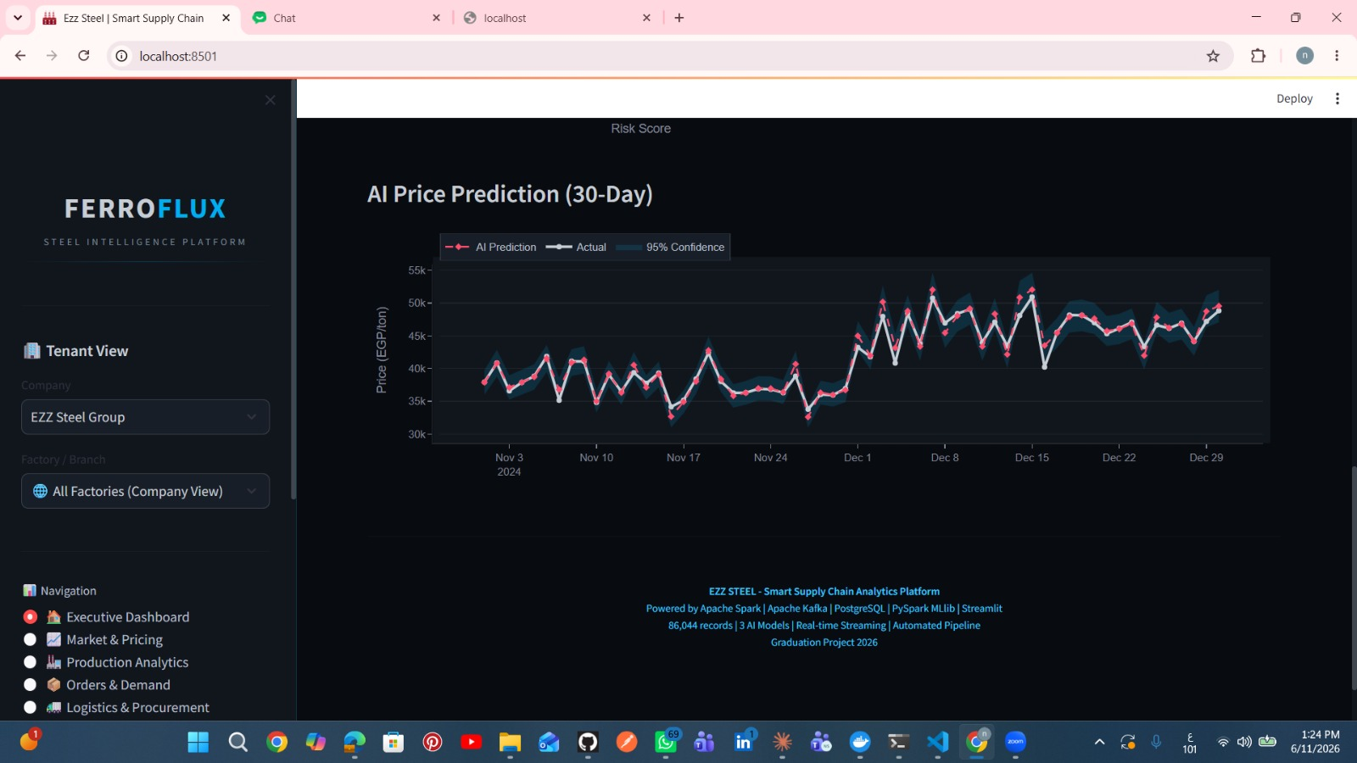
Streamlit Dashboard — Executive Summary Page
The Executive Summary is the default landing page of the dashboard. It provides an at-a-glance view of the company's operational health across all registered factories.
Screen Breakdown:
Sidebar Filters:
- Date range selector (default: last 30 days)
- Factory selector dropdown (All Factories / individual factory)
- Product type filter
- KPI Metric Cards (top row, 4 cards):
Each card shows:
- Metric name
- Current period value (large, bold)
- Delta vs. previous period (green arrow ▲ for improvement, red arrow ▼ for decline)
- Color status badge: 🟢 On Target / 🟡 Warning / 🔴 Below Threshold
- Card Example Value Delta
- Total Production (tons) 12,450 ▲ +3.2% vs last month
- Average Efficiency 74.8% ▼ −1.1% vs last month
- Total Revenue (EGP) 311.25M ▲ +5.7% vs last month
- On-Time Delivery 82.3% ▲ +0.8% vs last month
Combined Trend Chart:

- Time-series line chart (Plotly) with all four KPIs normalized to 0–100 scale
- Each KPI shown in a distinct color matching its metric card
- Hover tooltips show exact values on any date
Anomaly Flag Panel:
- Lists any dates in the selected range where a KPI breached its threshold
- Each flag shows: date, KPI name, actual value, threshold, severity badge

Step 2: Market Intelligence & Price Forecast
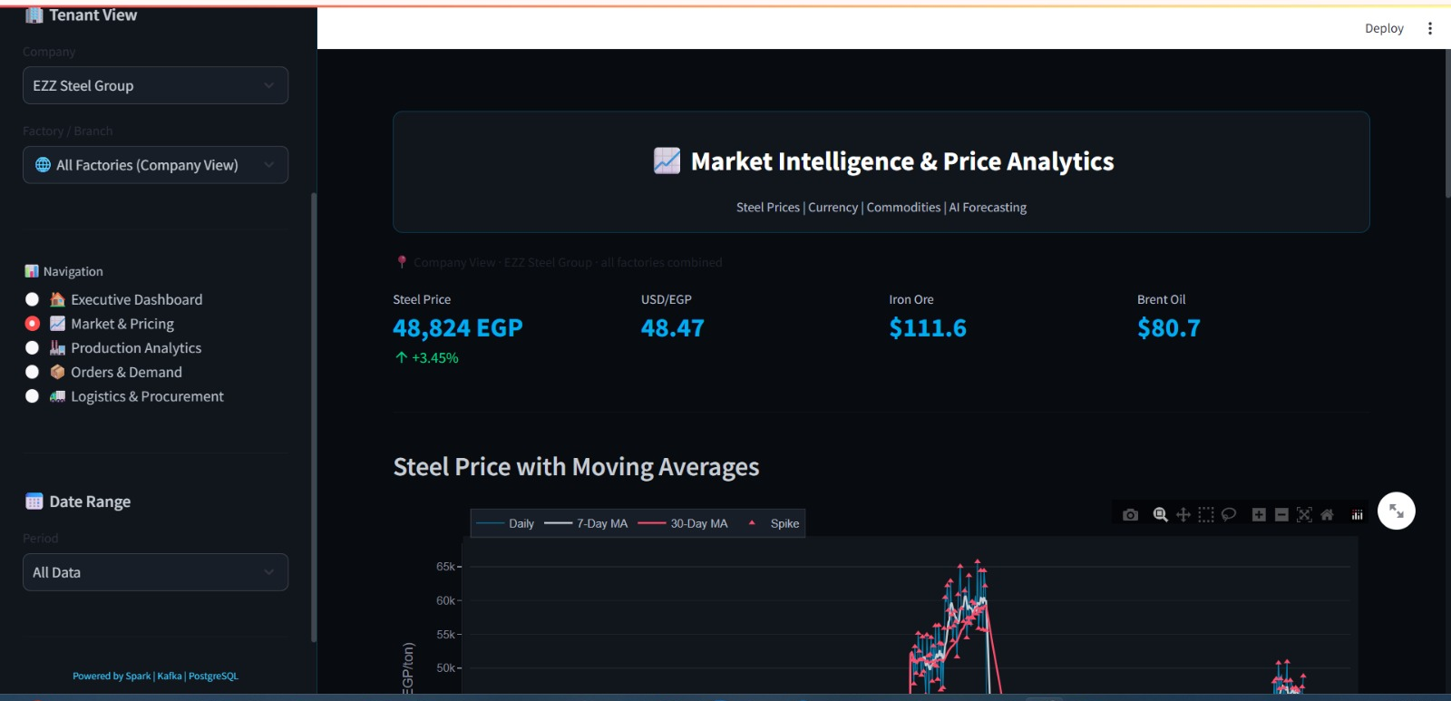
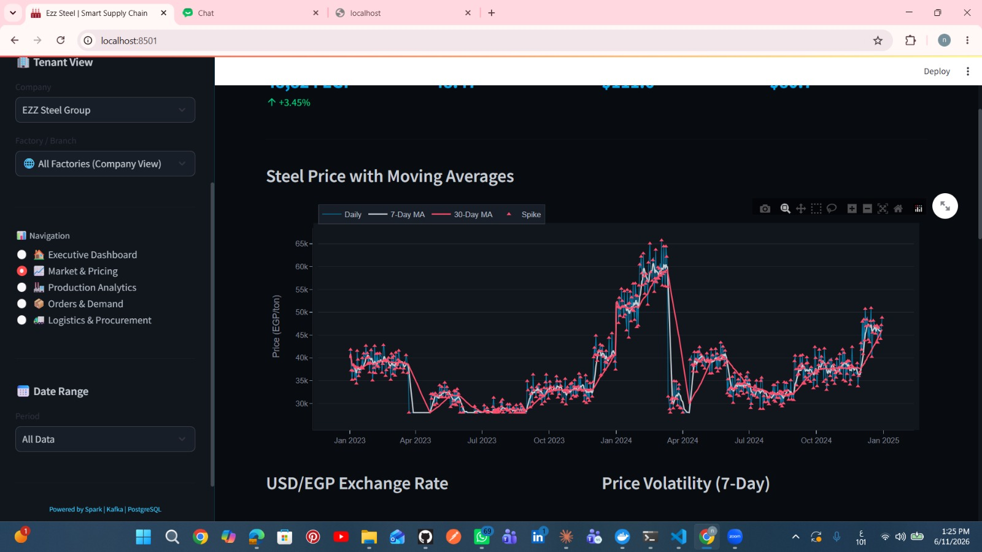
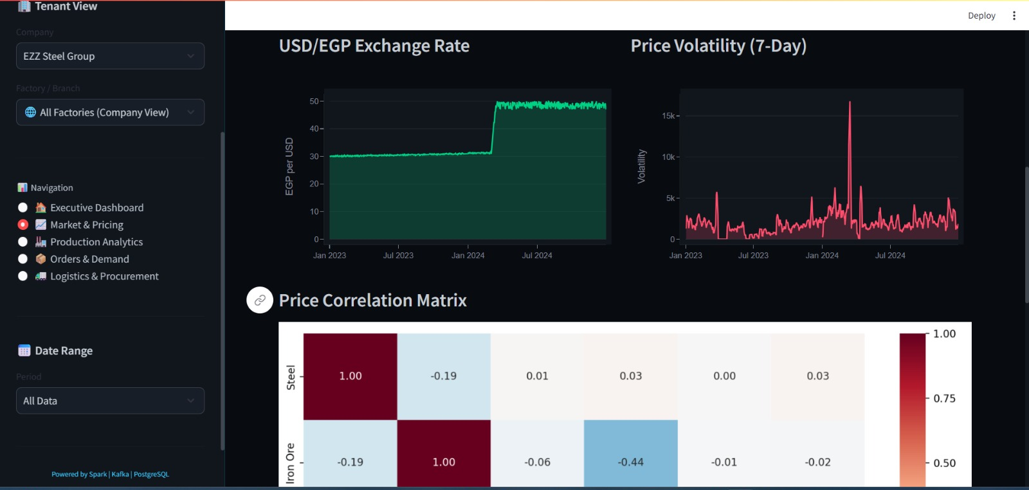
Streamlit Dashboard — Market Intelligence Page
The Market Intelligence page provides the complete picture of the steel and scrap price environment, including the ML-generated next-day price forecast.
Screen Breakdown:

Price Chart (Primary — Plotly Interactive):
- Steel price (EGP/ton) — solid blue line
- Scrap price (USD/ton) — solid orange line, secondary y-axis
- XGBoost next-day forecast — dashed green line with ±confidence band
- Forecast band is shaded green (below 30-day average = buy signal) or red (above = hold)
Model Performance Badge (Sidebar):
- R² = 0.9578
- MAPE = 1.61%
- Last retrain date
- Next scheduled retrain date
Derived Feature Panel:
Current values of the model's input features:
- price_lag_1d: yesterday's closing price
- price_ma_7d: 7-day moving average
- price_delta: change from yesterday
Forecast Interpretation Note:

Auto-generated text: "Today's forecast (25,430 EGP/ton) is 2.1% above the 30-day average. Market signal: HOLD — prices are trending upward."

Step 3: Production Analytics
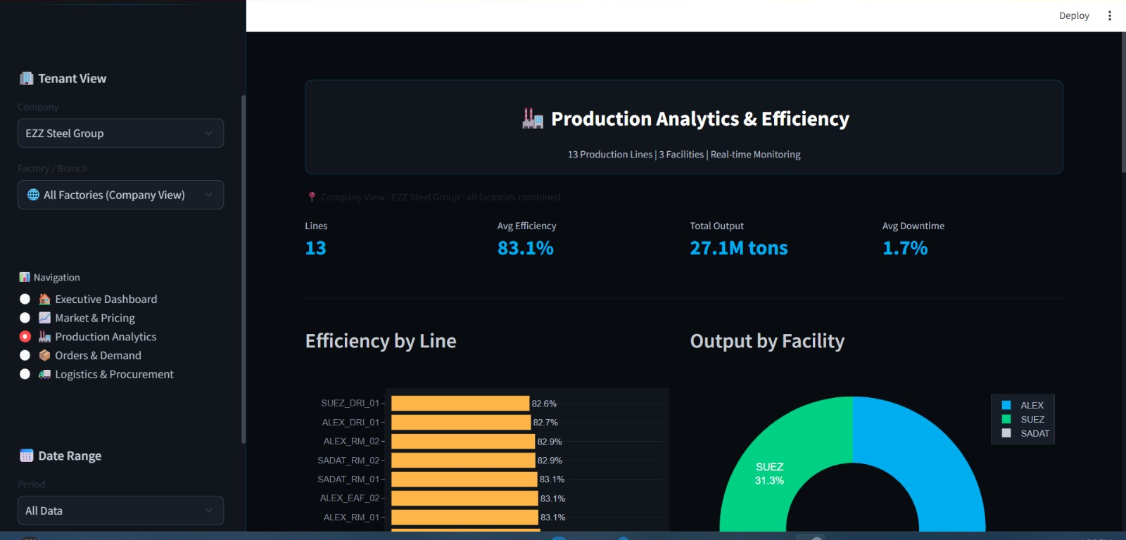
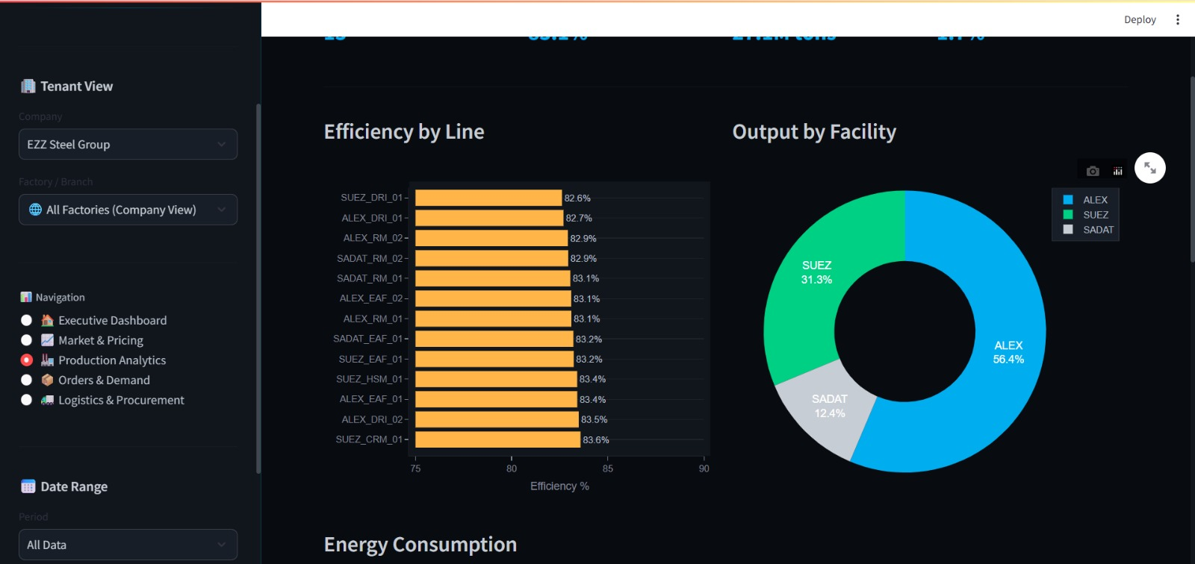
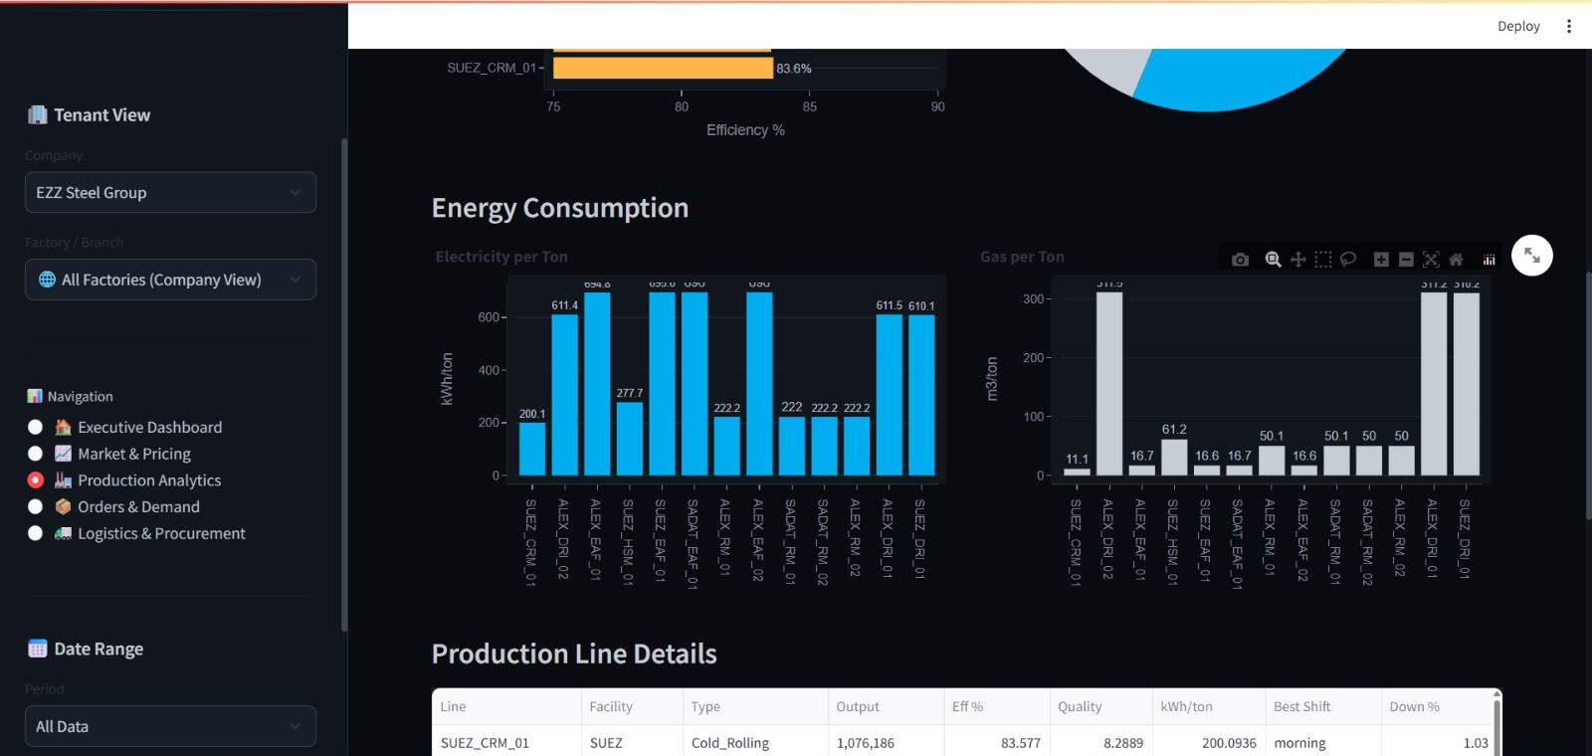
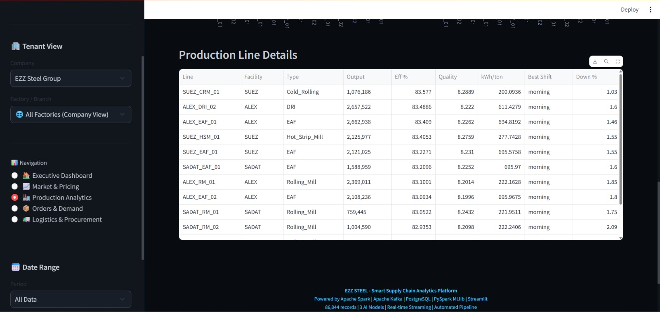
Streamlit Dashboard — Production Analytics Page

The Production Analytics page provides factory-level production visibility and efficiency monitoring.
Screen Breakdown:
Efficiency Calendar Heatmap:
- One cell per day in the selected date range
- Color intensity represents efficiency percentage
- Red cells = below threshold (default 70%)
- Hover tooltip: date, exact efficiency %, deviation from threshold
Production Volume Bar Chart:

- Daily tonnage per product type (rebar / wire rod / billets) as stacked bars
- Total tonnage line overlay on secondary axis
Shift Comparison Panel:
- Three horizontal bar charts: Morning / Afternoon / Night shift average efficiency
- Identifies whether anomalies are shift-specific or facility-wide
Anomaly Log Table:
- All flagged days: KPI type, actual value, threshold, alert dispatched (Yes/No)
- Sortable by date or severity

Step 4: Order Management
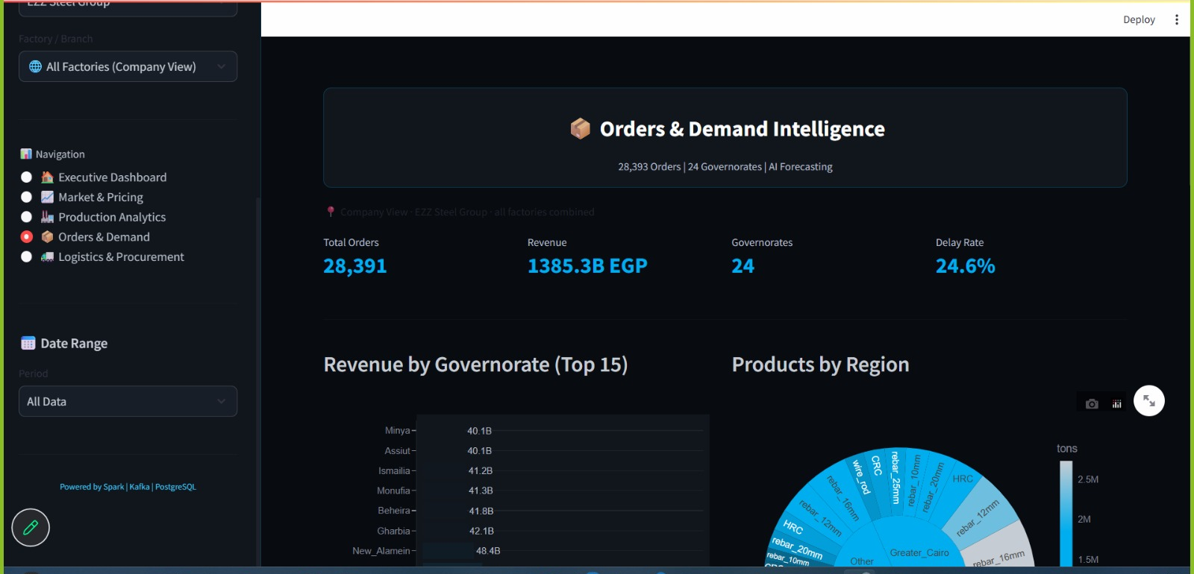
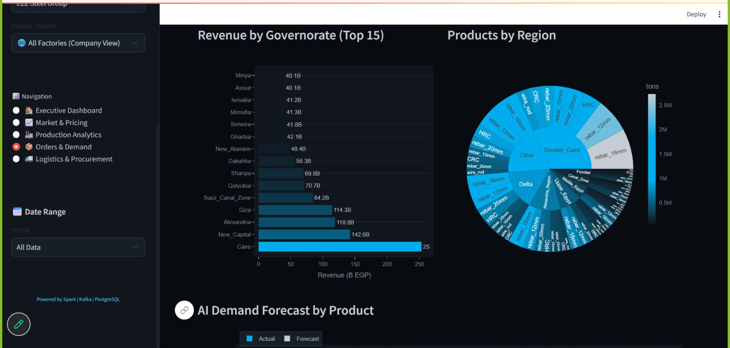
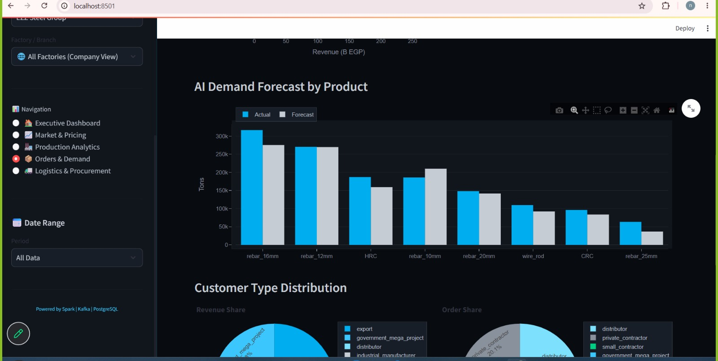
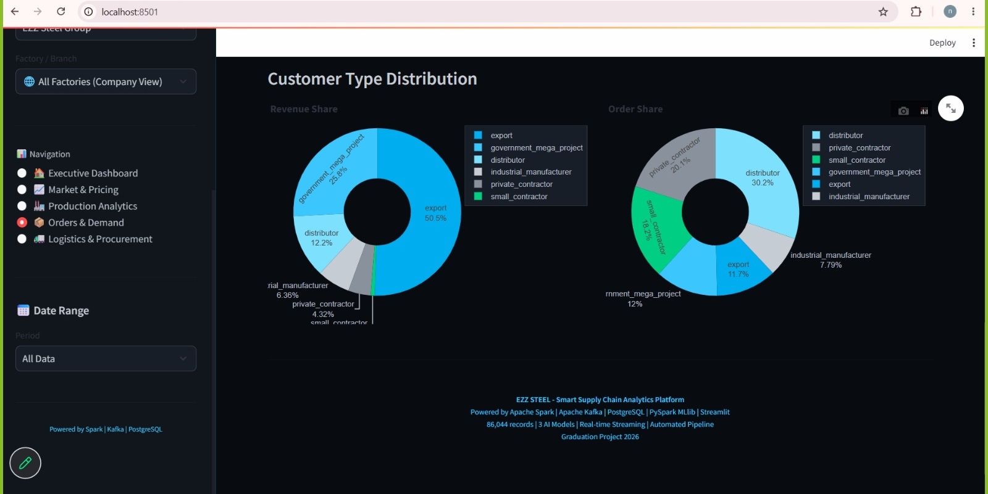
Streamlit Dashboard — Order Management Page

The Order Management page presents the complete order pipeline from placement through delivery.
Screen Breakdown:
Order Status Distribution Chart:
- Horizontal stacked bar: PENDING / SHIPPED / DELIVERED / CANCELLED
- Each segment shows count and total tonnage
Sortable Order Table:
Columns: Order ID · Product Type · Tonnage · Order Date · Expected Delivery · Actual Delivery · Delay (days)

Delay column is color-coded: green (0 days) / amber (1–3 days) / red (4+ days)
Filterable by status, product type, and date range
Average Delay Metric Card:
- Current month average delay in days
- Delta vs. previous month
Delivery Timeline (Gantt View):
- Horizontal bars per order showing planned vs. actual delivery span
- Delayed orders shown in red extending past the expected delivery date

Step 5: Logistics
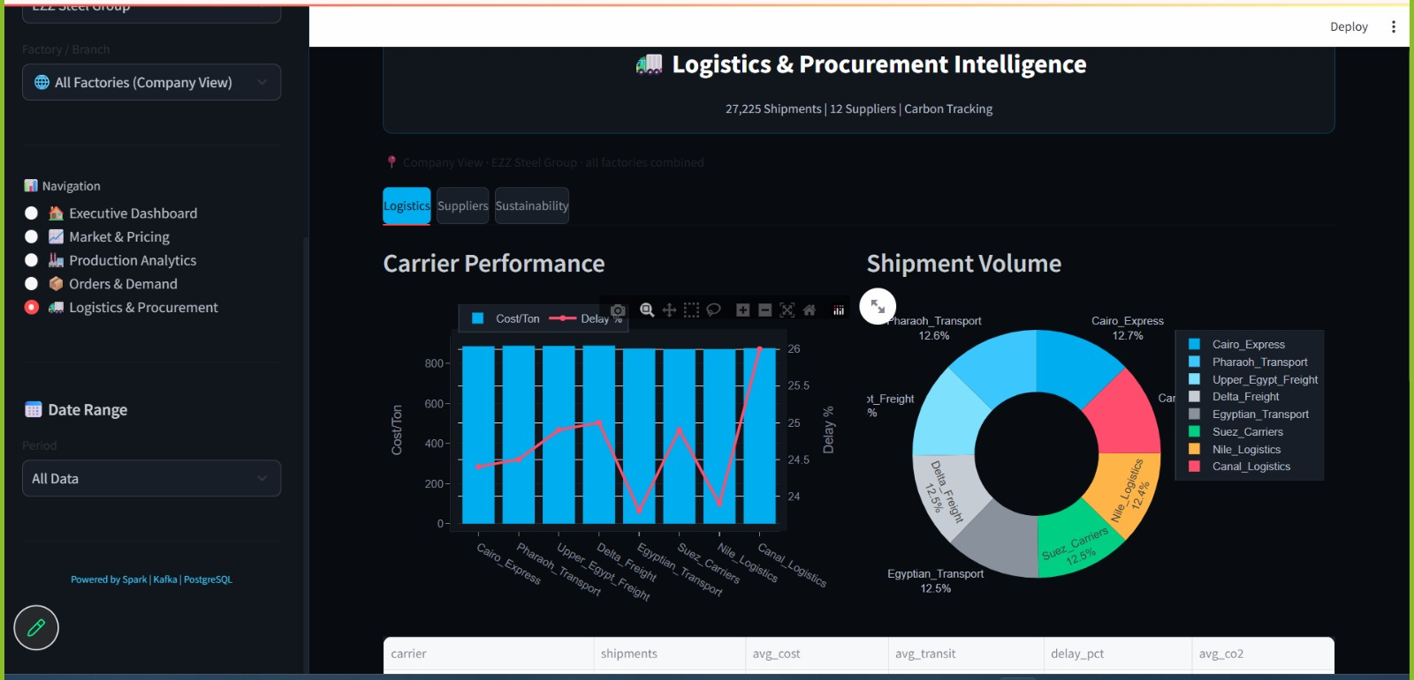
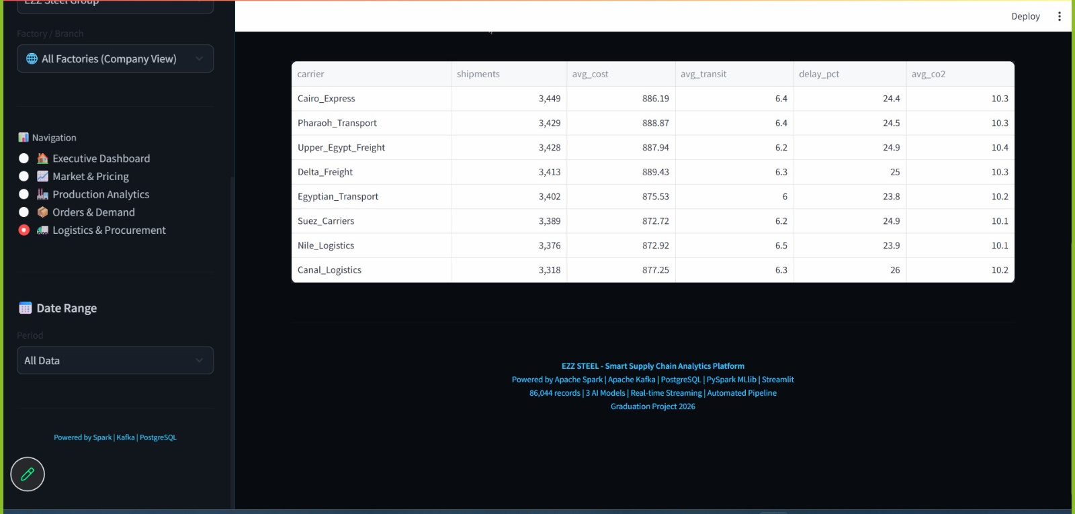
Streamlit Dashboard — Logistics Page
The Logistics page focuses on delivery geography and timing patterns.
Screen Breakdown:
Delay Frequency Histogram:
- X-axis: delay in days (0 to max observed)
- Y-axis: count of orders
- Vertical threshold line at day 0 separating on-time from delayed
Delivery by Product Type:

- Grouped bar chart showing average delay per product type
- Identifies which products consistently experience delivery issues
Governorate Distribution Map (if coordinates available):
- Egyptian governorate map colored by average delivery delay
- Hover tooltip: governorate name, order count, average delay
On-Time Rate Trend:
- Monthly on-time delivery percentage line chart with threshold line

Step 6: Supplier Risk Scoring
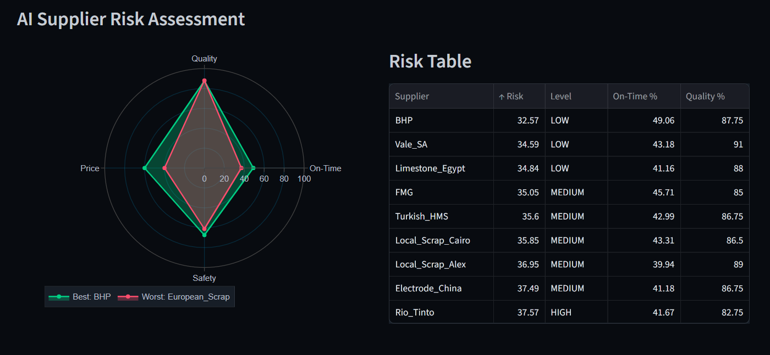
Streamlit Dashboard — Supplier Risk Scoring Page

The Supplier Risk Scoring page is the operational home of the XGBoost supplier risk classification model and the most directly actionable page of the dashboard.
- Screen Breakdown:
Risk Summary Banner (top of page):
Three color-coded metric chips: 🟢 LOW (12) · 🟡 MEDIUM (5) · 🔴 HIGH (3)
If any HIGH-risk suppliers exist: red alert box listing their names and primary risk factor
Supplier Leaderboard Table:
Columns: Supplier ID · Risk Label · Risk Score (0–1) · On-Time Rate · Quality Score · Avg Delay (days) · Trend

Risk Label column shows colored badges: green LOW / amber MEDIUM / red HIGH
Trend column shows 90-day direction: ↑ Improving / → Stable / ↓ Deteriorating
Sortable by any column
Risk Score Trend Chart:
- When a supplier row is selected, a 90-day risk score trend line appears below the table
- Distinguishes between chronically high-risk suppliers and recently deteriorated ones
- Threshold line at the HIGH-risk boundary (0.70)
Feature Contribution Panel:
- For the selected supplier: bar chart of the top 3 features driving their risk score
- Example: "on_time_rate (58%) contributes 42% of risk score — below safe threshold of 70%"
Importance of This Page:
- 100% precision on HIGH-risk classification means every red-flagged supplier genuinely warrants immediate contract review — zero false alarms.
- The feature contribution panel tells the manager specifically why a supplier was flagged, enabling targeted corrective conversations.
- The 90-day trend distinguishes a supplier who has always been unreliable from one who recently started deteriorating — different situations calling for different responses.
Note: The screenshots shown above represent the implemented portal and dashboard at the time of submission. Both applications are actively deployed and accessible via the project QR codes on the poster. Minor UI refinements may be applied as feedback is incorporated following the capstone presentation.

Chapter 6

Conclusion and future work

6.1 Conclusion
FerroFlux has successfully demonstrated that a small, purpose-built big data engineering team can deliver a production-grade, end-to-end analytics platform for an industrial domain that has historically lacked affordable data infrastructure. The platform unifies real-time event streaming (Apache Kafka), distributed ETL (Apache Spark, medallion architecture), pipeline orchestration (Apache Airflow), machine learning inference (XGBoost, Random Forest, Prophet), multi-tenant API security (FastAPI, JWT, bcrypt), interactive analytics (Streamlit), and automated alerting (n8n) into a single coherent system deployed at near-zero cost on cloud infrastructure.

The three ML models achieved their target accuracy thresholds: the price forecasting model reached R²=0.9578 and MAPE=1.61%, enabling sub-2% error procurement guidance; the demand model achieved R²=0.8030, providing directional 30-day planning signals; and the supplier risk classifier achieved 94.78% overall accuracy with 100% precision on the HIGH-risk class — the most operationally critical outcome, as it ensures that every flagged supplier genuinely warrants review.

The multi-tenant portal and dashboard were validated in end-to-end system tests covering three concurrent tenants with zero cross-tenant data leakage, page load times under 2 seconds, and alert dispatch within 15 minutes of threshold breach. Informal usability testing with five target-role participants confirmed that all primary user journeys (registration, upload, KPI review, supplier risk review, password reset) are completable without technical assistance.

FerroFlux proves that the gap between enterprise analytics capabilities and mid-size industrial producer needs is bridgeable with open-source tooling, cloud deployment platforms, and a well-architected data model — and that doing so within a university capstone timeframe and budget is achievable.

6.2 Future Work
Several enhancements are planned for future development iterations:

Live steel exchange price feed integration. The current price ingestion relies on manually curated market data. Integrating a live API feed from the Egyptian Exchange or a commodity data provider (e.g., LME, SteelBenchmarker) would provide fully automated, real-time price signals without any manual data upload step.

LSTM-based price forecasting. An LSTM or Transformer time-series model could capture longer-range temporal dependencies in steel price data that the current XGBoost model, which is limited to engineered lag features, may miss. A comparative study between XGBoost and deep learning approaches on 5+ years of price data would quantify the potential accuracy improvement.

Mobile-responsive portal. The current FastAPI portal is accessible on mobile browsers but is not optimized for small screens. A dedicated mobile-responsive UI (either React-based or using Streamlit's responsive layout features) would make the KPI monitoring and alert management workflows accessible to factory managers on the production floor.

ERP integration. Many mid-size Egyptian producers use local ERP systems (e.g., Microsoft Dynamics NAV, or locally developed systems). An ETL adapter that reads directly from ERP database exports would eliminate the manual Excel upload step, reducing data latency and upload errors.

Demand forecasting improvement. The current demand model's MAPE of 35.74% reflects the high volatility of industrial order data. Incorporating macroeconomic indicators (construction permit volumes, GDP growth, government infrastructure project spending) as external regressors in a Prophet model could significantly improve forecast accuracy.

Multi-language UI. Adding Arabic-language interface support for the portal and dashboard would improve accessibility for factory managers and procurement officers who prefer to operate in Arabic, particularly for alert messages and report labels.

Role-based access control expansion. The current portal supports two roles (administrator, factory manager). Expanding to include read-only analyst roles, auditor roles with full data export access, and supplier-facing portals where risk scores are shared with suppliers would broaden the platform's utility across the supply chain.

References

[1] Dean, J., & Ghemawat, S. (2008). MapReduce: Simplified data processing on large clusters. Communications of the ACM, 51(1), 107–113.

[2] Kreps, J., Narkhede, N., & Rao, J. (2011). Kafka: A distributed messaging system for log processing. Proceedings of the NetDB Workshop.

[3] Chambers, B., & Zaharia, M. (2018). Spark: The Definitive Guide. O'Reilly Media.

[4] Kleppmann, M. (2017). Designing Data-Intensive Applications. O'Reilly Media.

[5] Chen, T., & Guestrin, C. (2016). XGBoost: A scalable tree boosting system. Proceedings of the 22nd ACM SIGKDD International Conference on Knowledge Discovery and Data Mining, 785–794.

[6] Taylor, S. J., & Letham, B. (2018). Forecasting at scale. The American Statistician, 72(1), 37–45. (Prophet)

[7] Apache Software Foundation. (2024). Apache Kafka Documentation, Release 3.6. https://kafka.apache.org/documentation/

[8] Apache Software Foundation. (2024). Apache Spark Documentation, Release 3.5. https://spark.apache.org/docs/latest/

[9] Apache Software Foundation. (2024). Apache Airflow Documentation, Release 2.8. https://airflow.apache.org/docs/

[10] Databricks. (2023). Medallion Architecture: A data design pattern for data lakehouses. https://www.databricks.com/glossary/medallion-architecture

[11] Ramírez, S. (2024). FastAPI Documentation, Release 0.111. https://fastapi.tiangolo.com/

[12] Streamlit Inc. (2024). Streamlit Documentation, Release 1.33. https://docs.streamlit.io/

[13] PostgreSQL Global Development Group. (2024). PostgreSQL 16 Documentation. https://www.postgresql.org/docs/16/

[14] Breiman, L. (2001). Random forests. Machine Learning, 45(1), 5–32.

[15] Neon Technologies. (2024). Neon Serverless PostgreSQL Documentation. https://neon.tech/docs/

[16] n8n GmbH. (2024). n8n Workflow Automation Documentation. https://docs.n8n.io/

[17] Docker Inc. (2024). Docker Documentation. https://docs.docker.com/

[18] Merkel, D. (2014). Docker: Lightweight Linux containers for consistent development and deployment. Linux Journal, 2014(239), 2.

